

|  |  |
| --- | --- |
| Module code and name: | Distributed Systems and Cloud Computing |
| Assessment: | CW 1 |
| Student ID: | 00012907 |
| Submission deadline: | 10/31/2024 |
| Wordcount |  |
| Results date and type of feedback |  |
| Result (Pass or Fail) |  |
| **Feedback** | |
|  | |

**DSCC CW1**

## Project Overview

The project focuses on Library Management System that users are able to perform CRUD operations, like create, retrieve, update, and delete book data within the database. Project is built on ASP.NET Core to create a distributed application with both a microservice-based API and an MVC front-end interface.

Migrations have been integrated in order to support the database schema updates, and SQL queries with insert statements to populate the tables for testing and demonstration. The MVC application created with controllers, models and views, hosted on a Windows Server instance with IIS, serves as the front-end, connecting to the API for data operations.

GitHub was used for version control and deployment, and the deploying process was done using AWS CodeDeploy, which pulls the code directly from the repositories. The application was hosted on three AWS EC2 instances: one for the ASP.NET application, another for the API, and a separate database server.

**Technologies**: ASP.NET Core, AWS EC2, AWS CodeDeploy, GitHub, ASP.MVC

**MVC front-end**

**Structured Models in MVC**

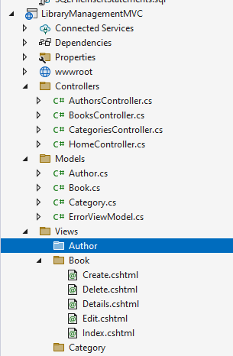

**Author Mode**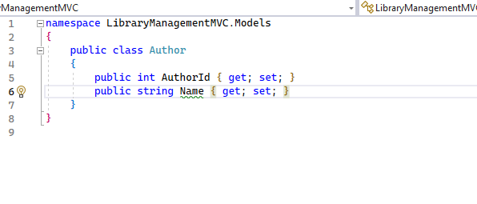

**Book Model**

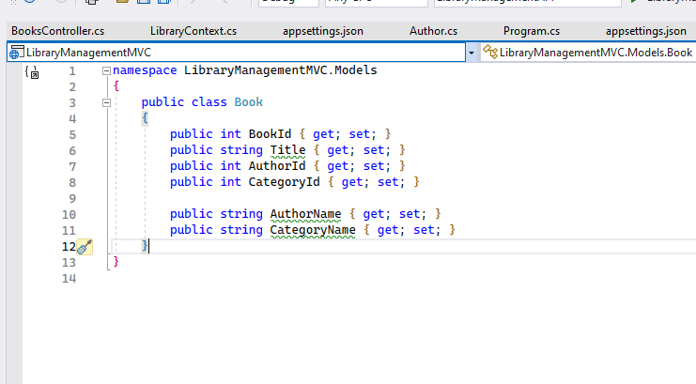

**Category Model**

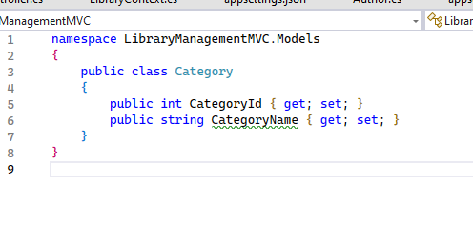

**ErrorView Model**

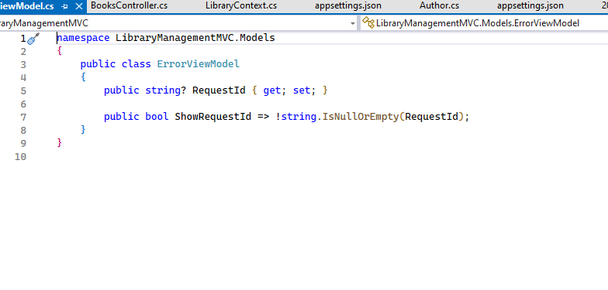

These models serve as data structures that your MVC controllers and views will use to handle and display data from your microservice API.

**Screenshots of MVC with CRUD Requests to API**

**MVC Forms**

Create

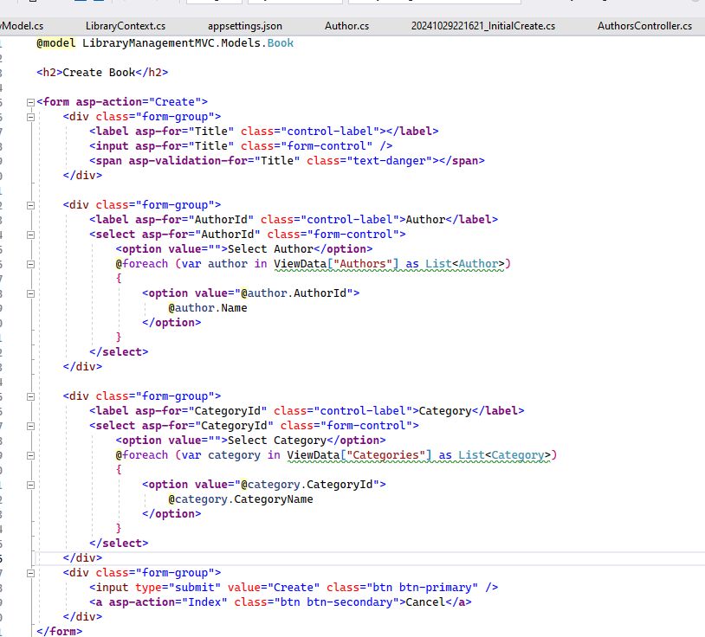

Delete

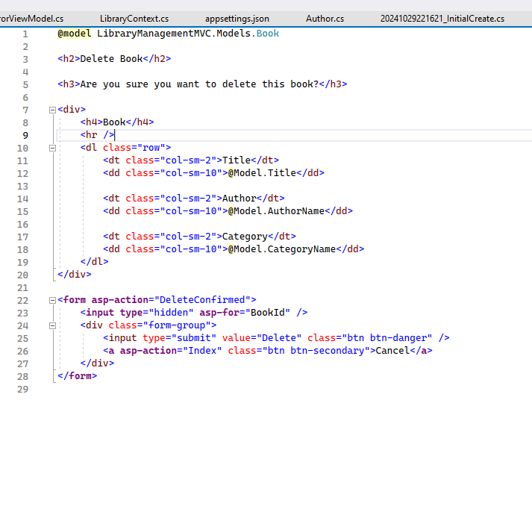

Details

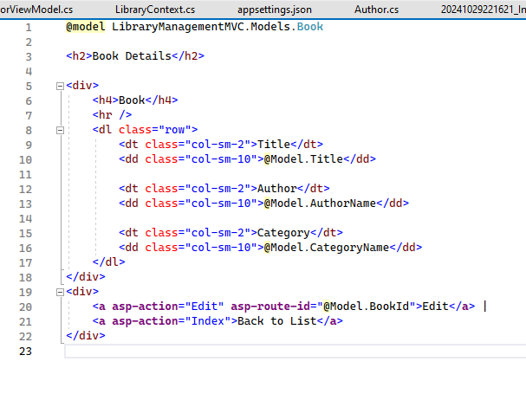

Edit

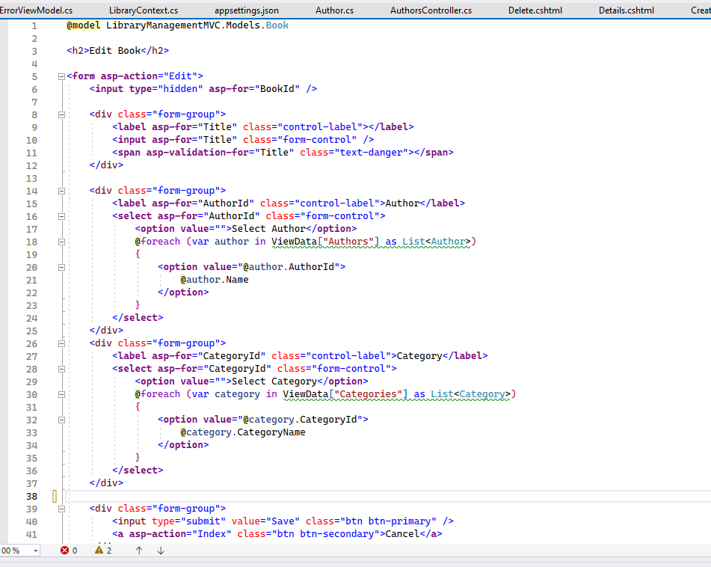

Index

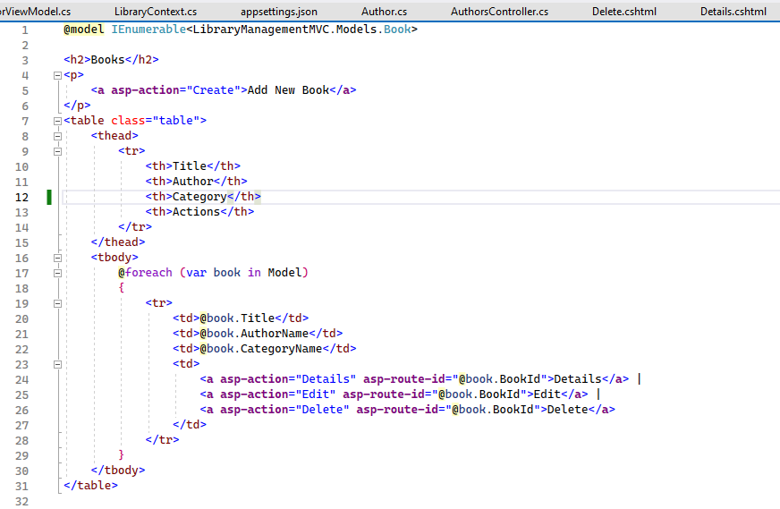

* *Viewing: Screenshots of data being displayed in the MVC interface.*
* *Creating: Screenshots of data creation forms or actions in MVC.*
* *Modifying: Screenshots of data modification forms or actions MVC.*
* *Deleting: Screenshots of data deletion actions in MVC.*

**Microservice API and DB Instances**

**Structured Models in MVC**

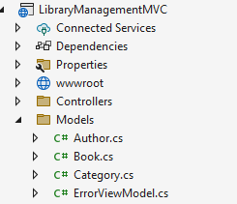

Author Model

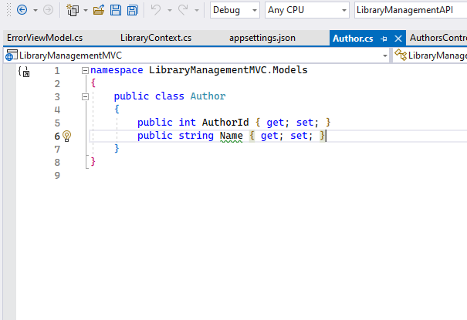

Book Model

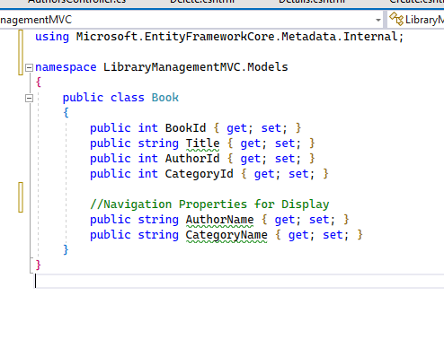

Category Model

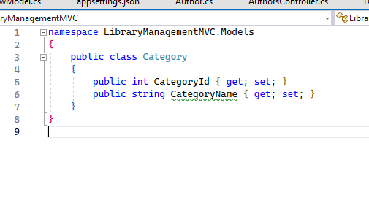

**CRUD Operations**

BooksController with full CRUD operations

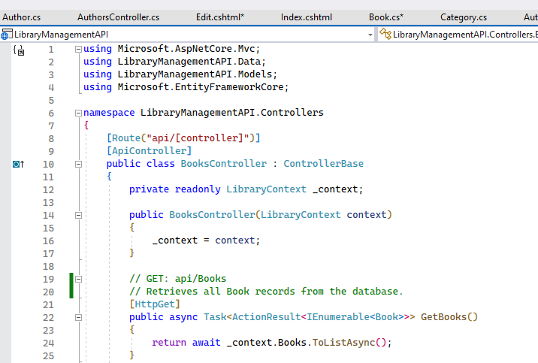

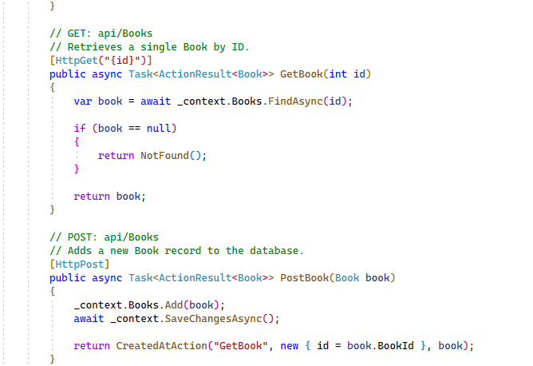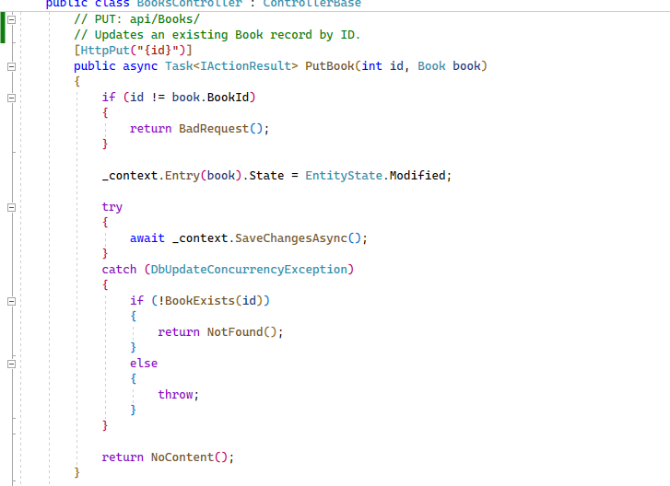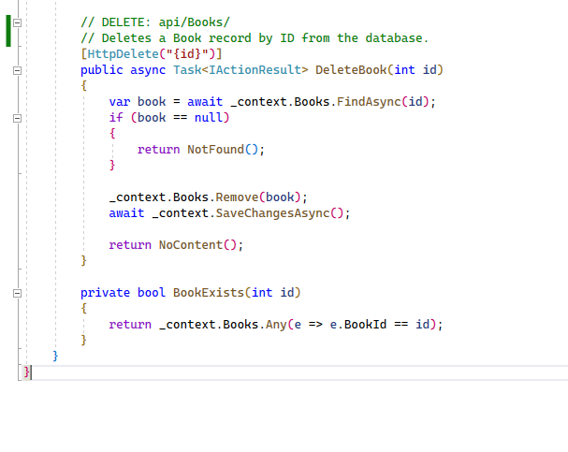

AuthorsController with only read actions

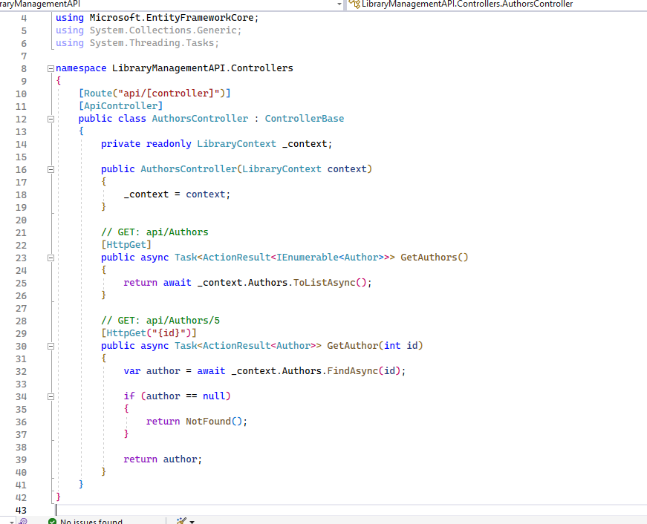

CategoriesController with only read actions

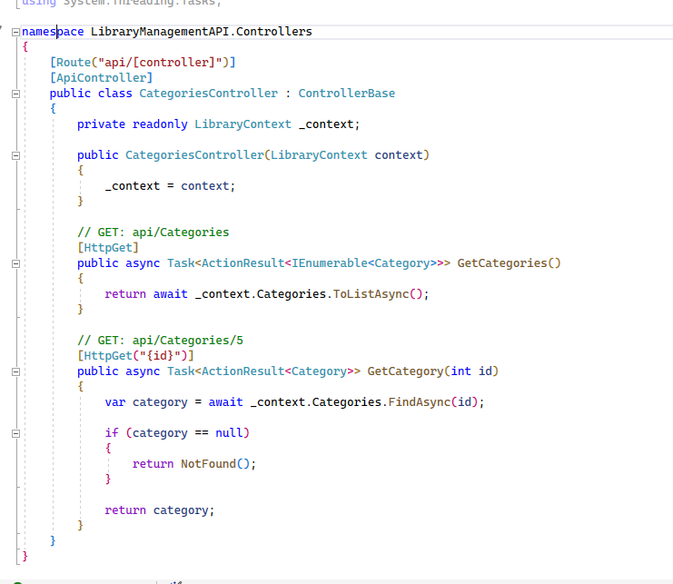

**Functioning API that has all connections and working**

Swagger UI

**Books table**

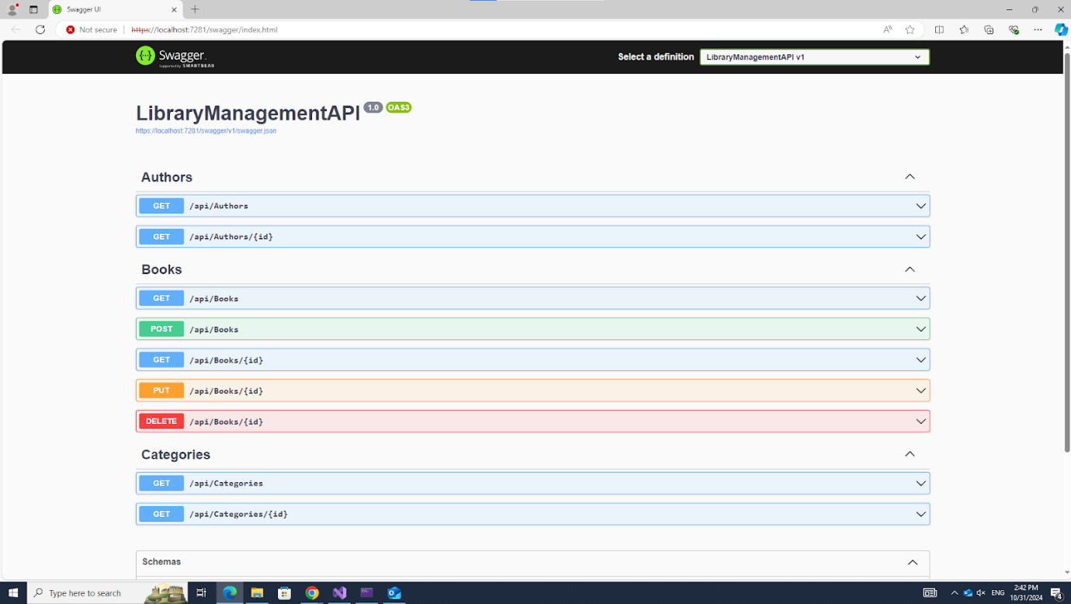

**GET**

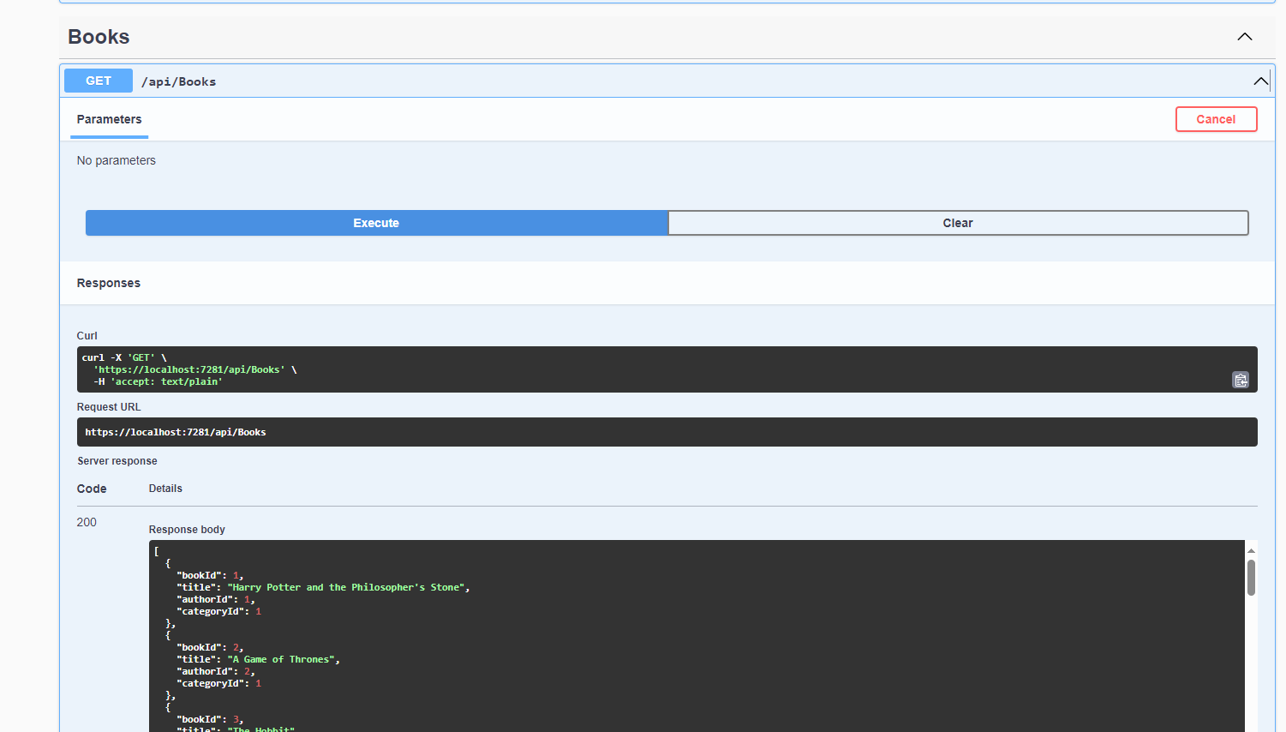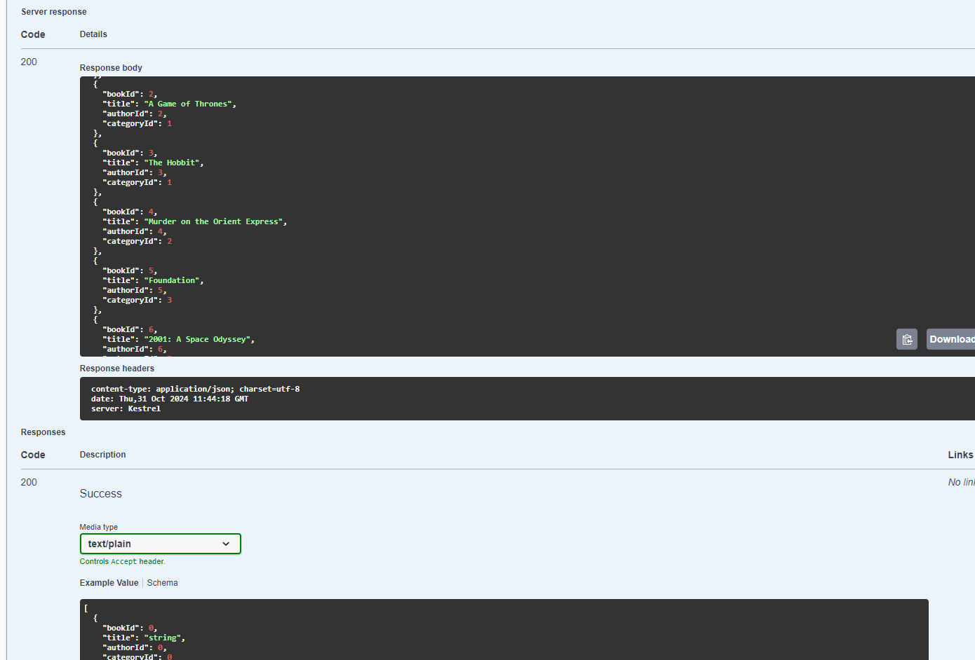

**POST**

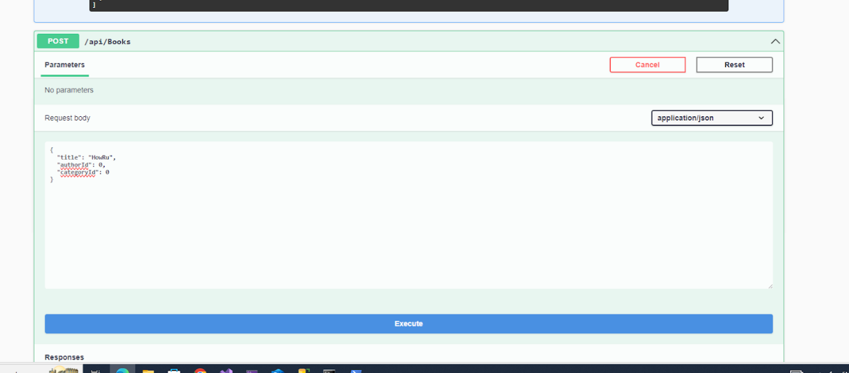

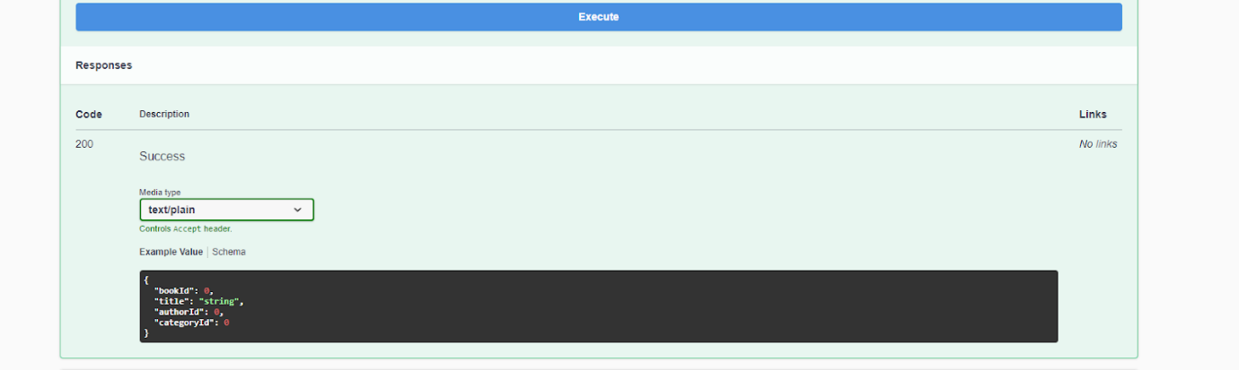

**GetById**

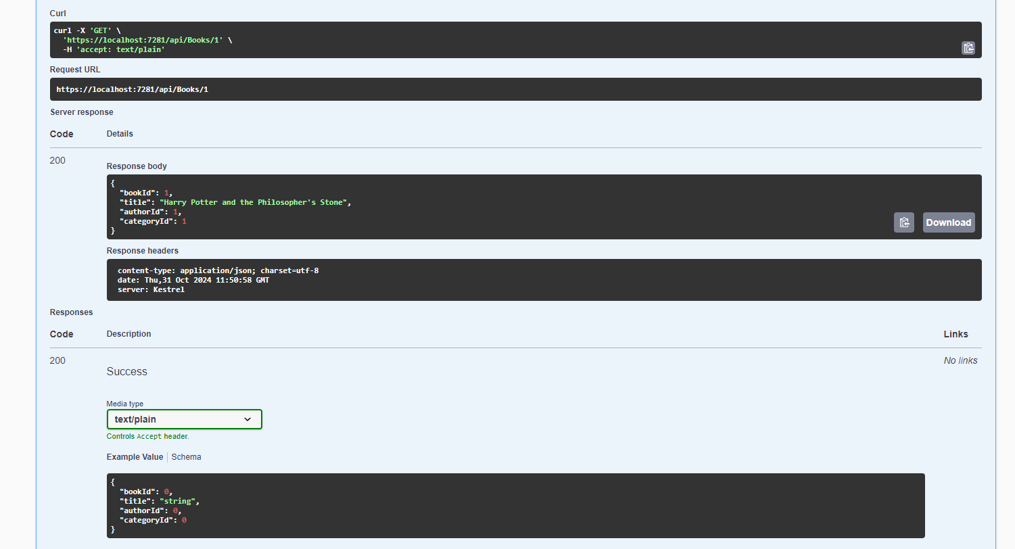

**PUT**

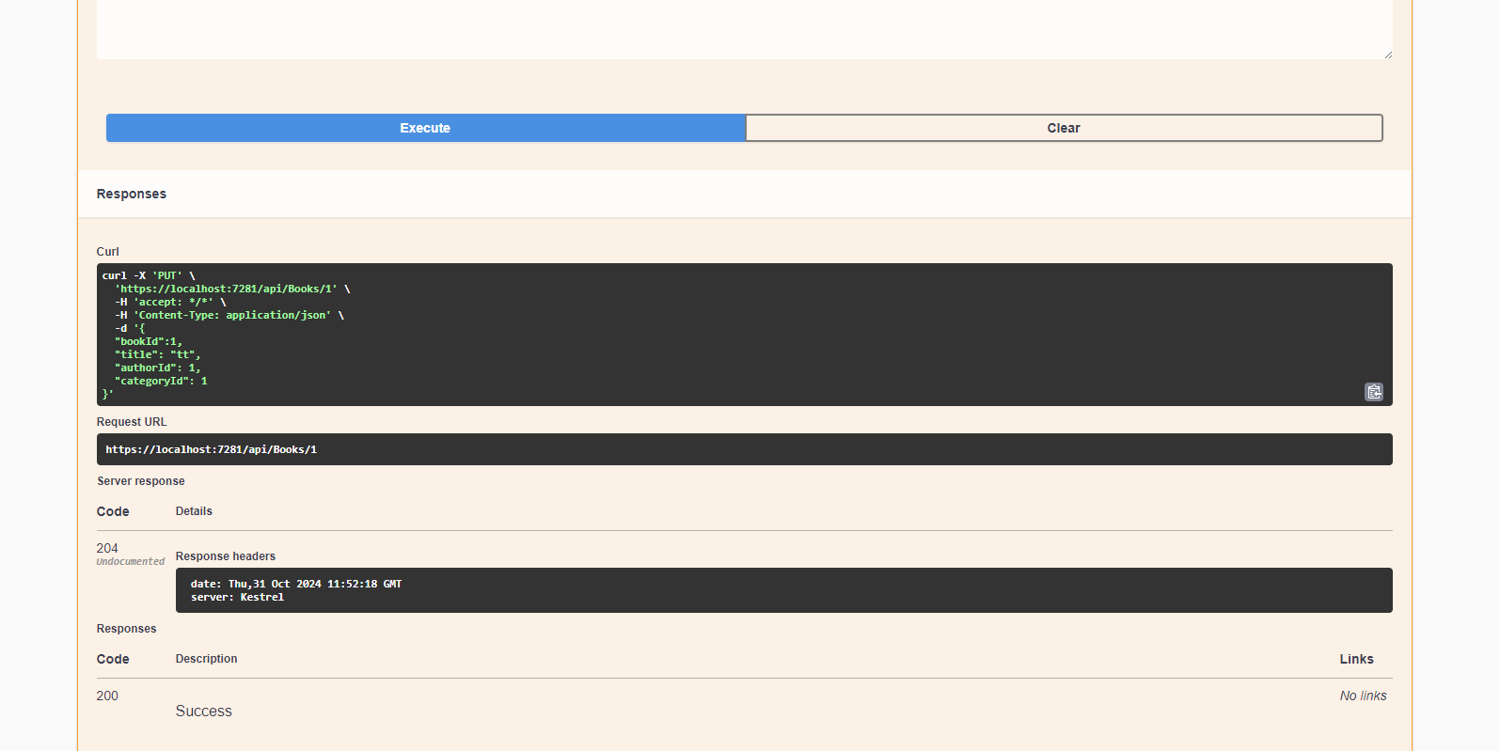

**DELETE**

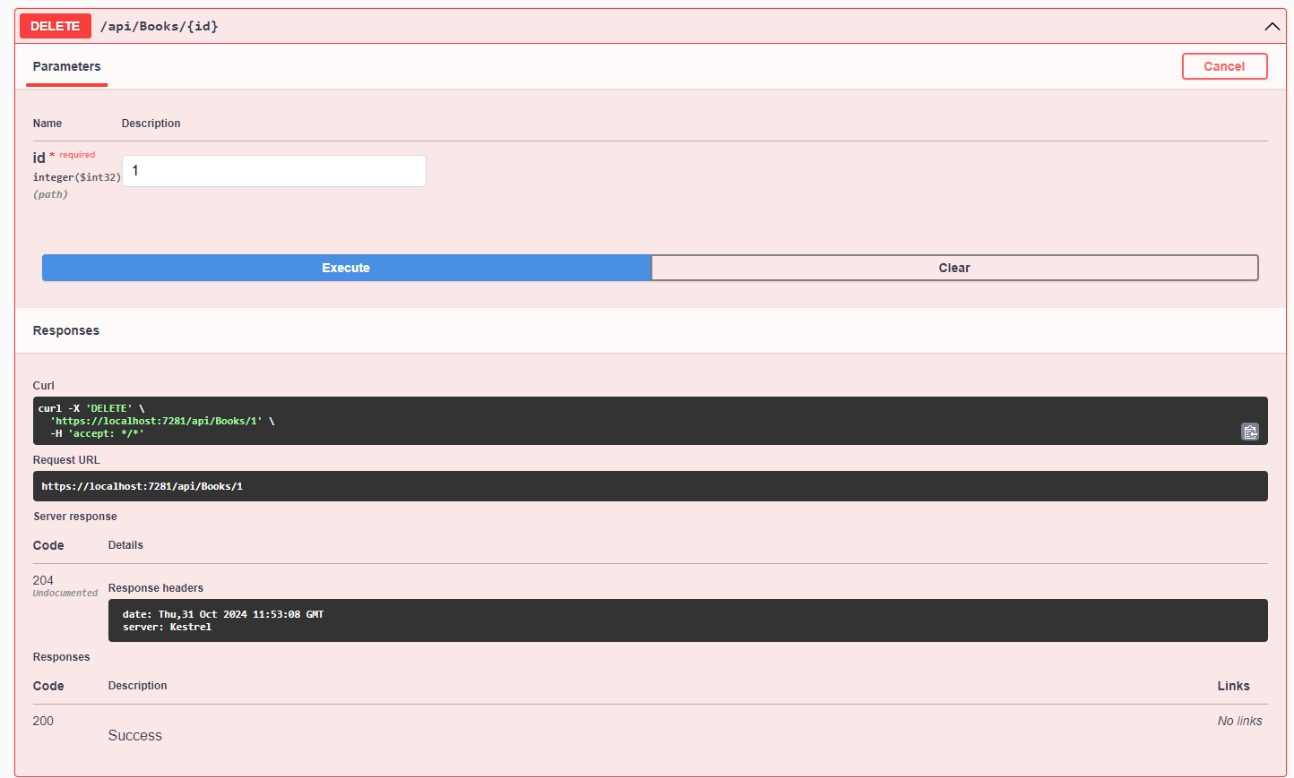

Categories Table (Read-only)

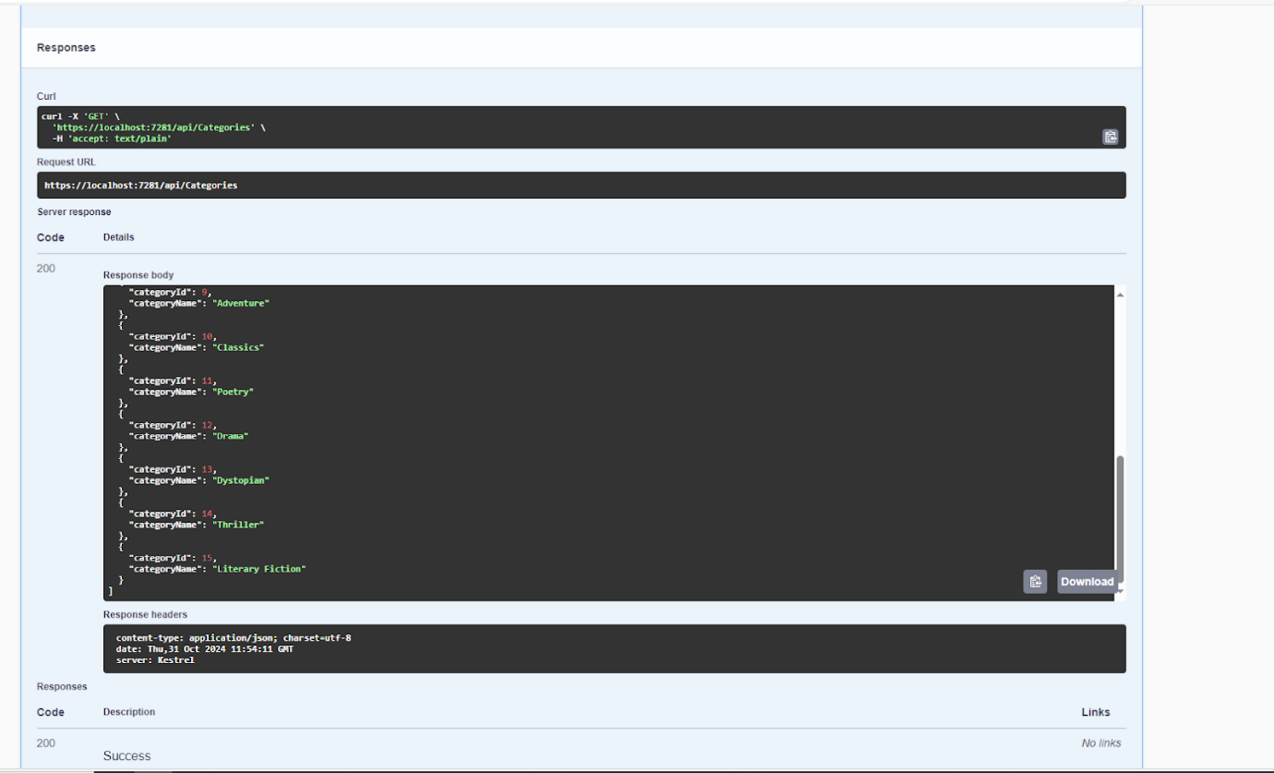

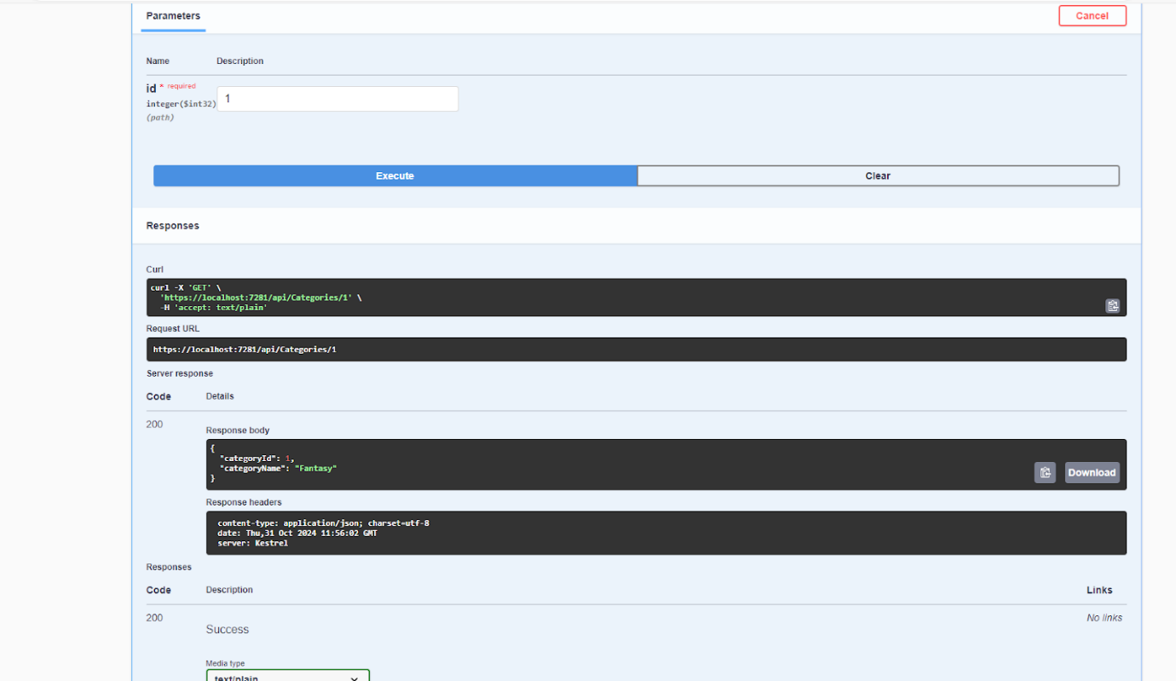

Authors Table (Read-only)

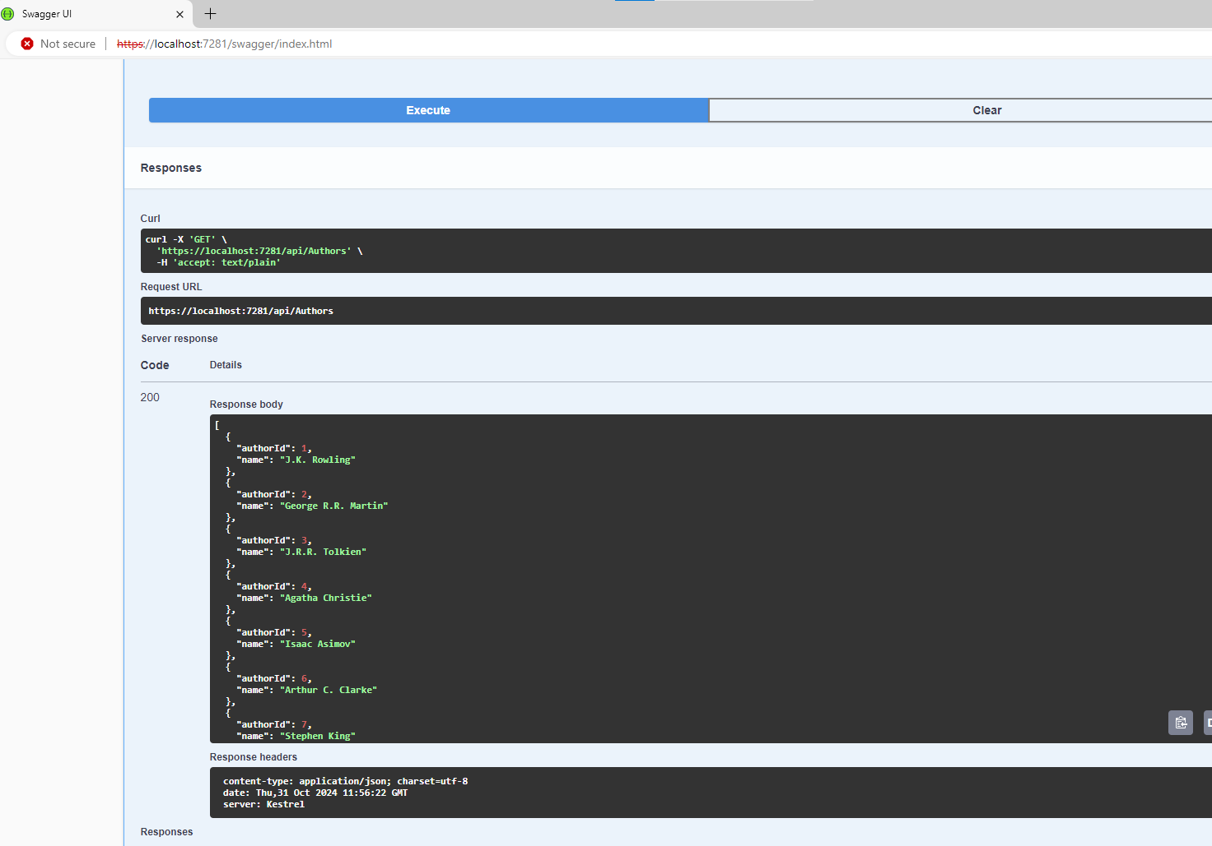

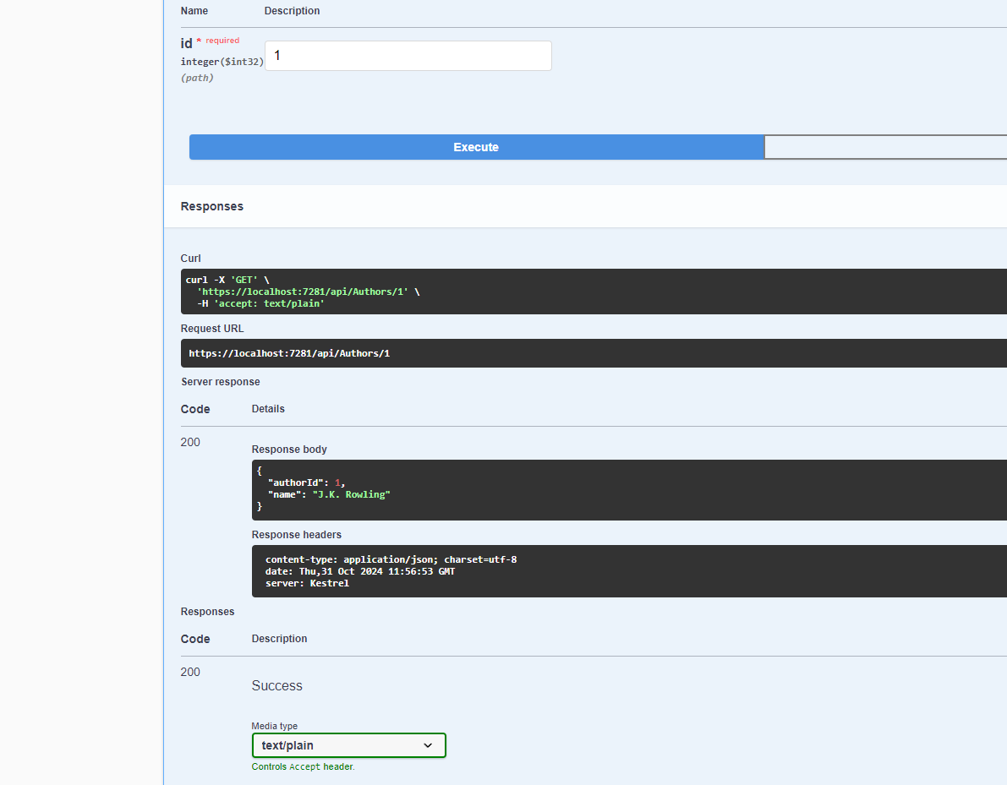

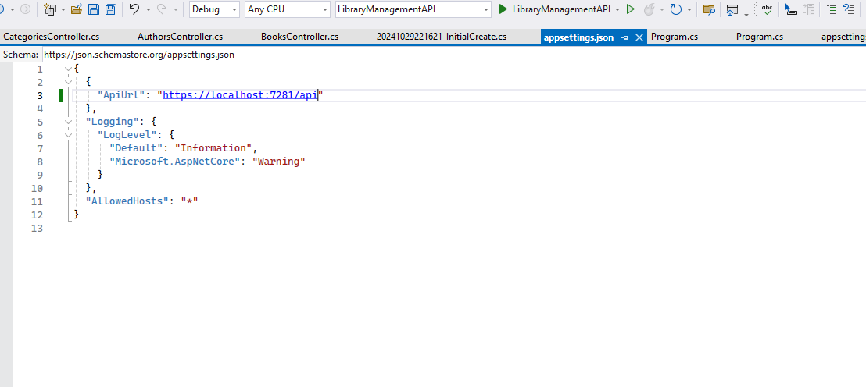

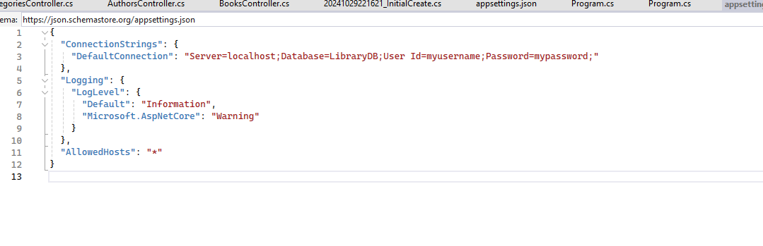

**Database Server Setup**

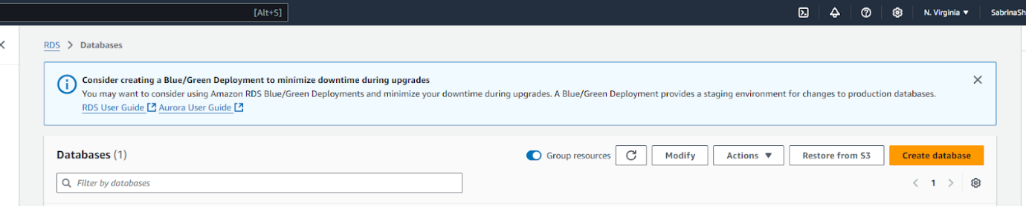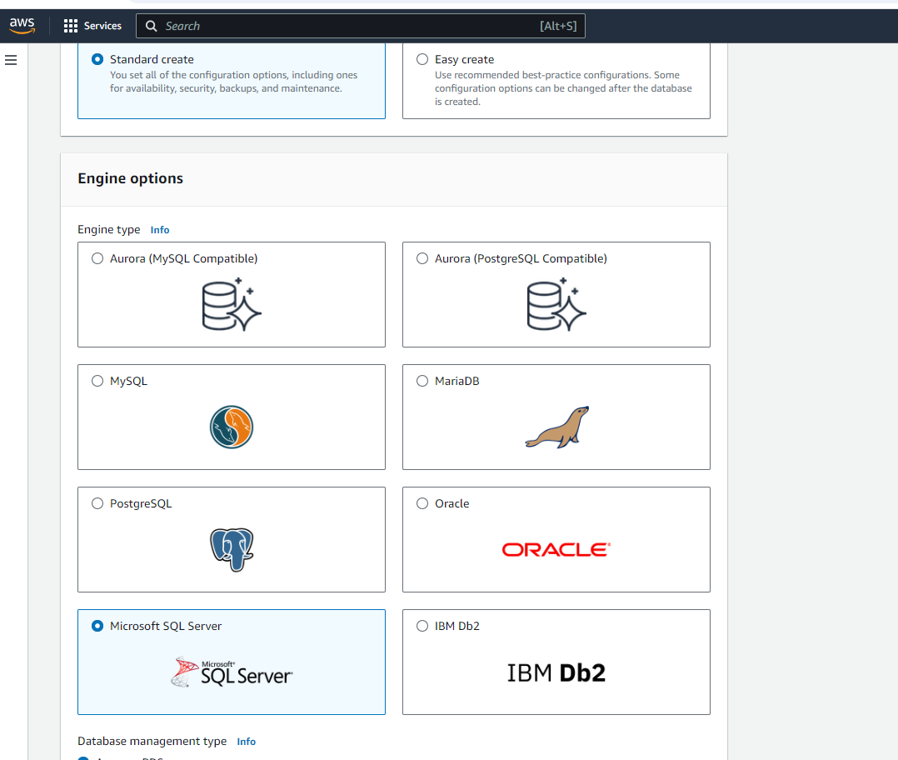

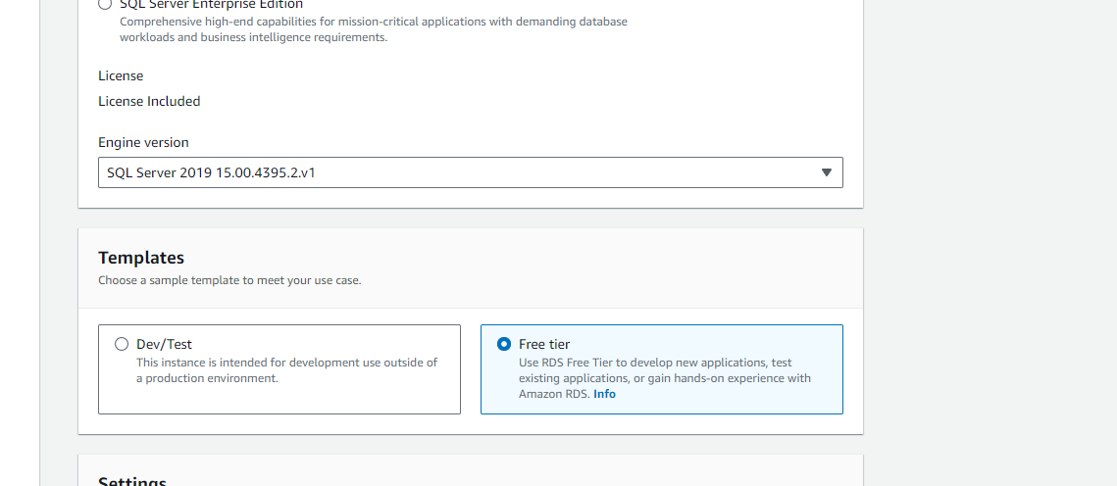

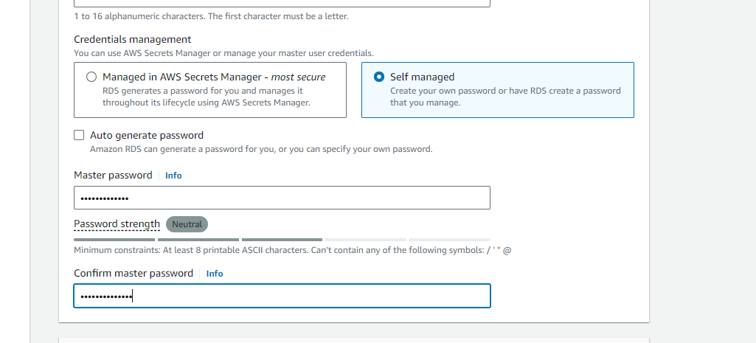

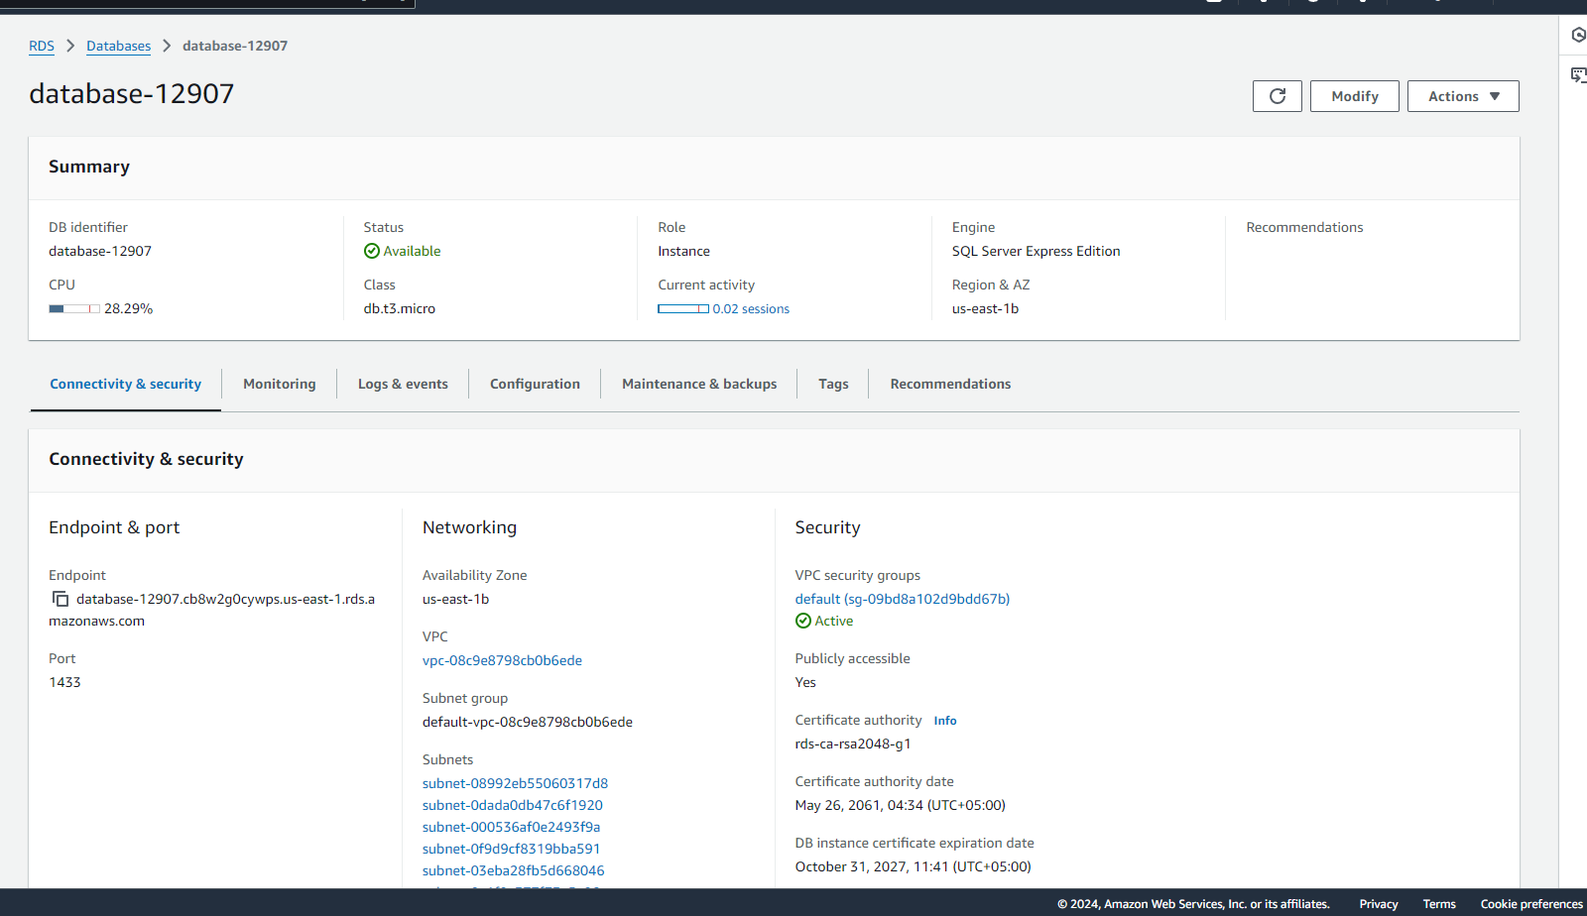

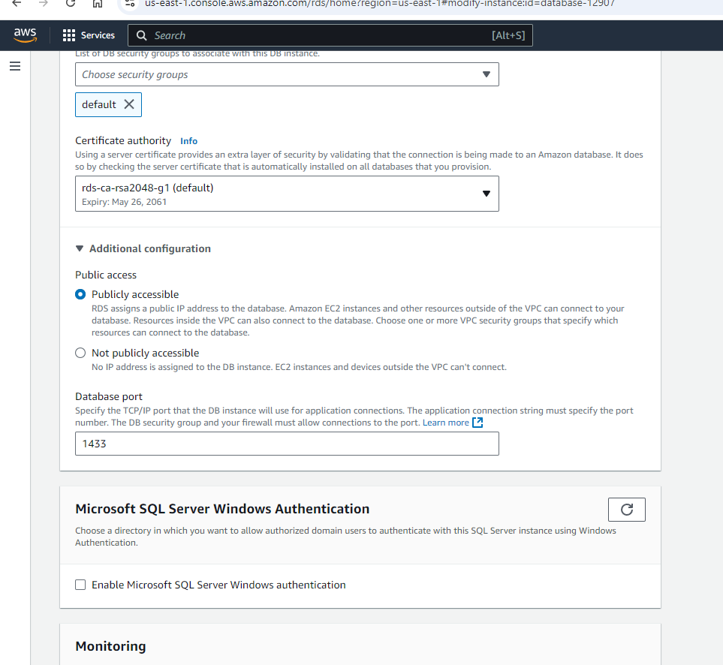

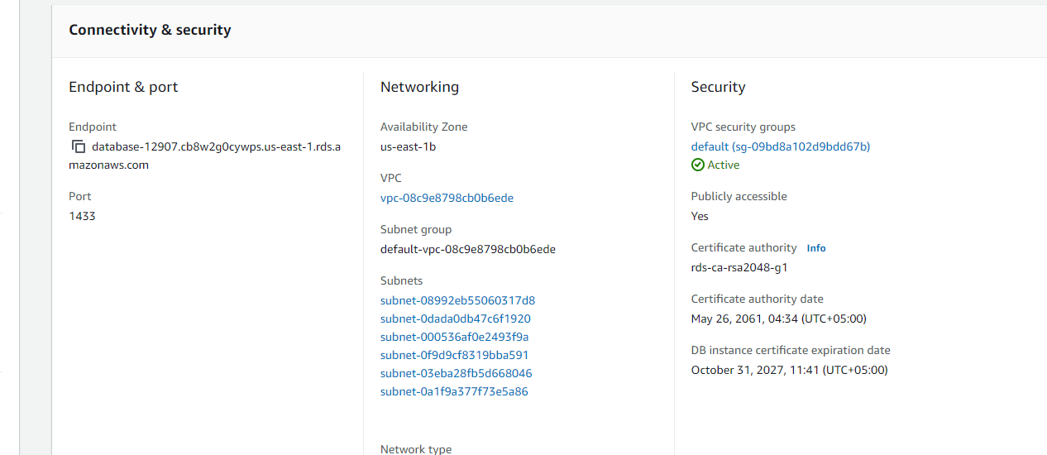

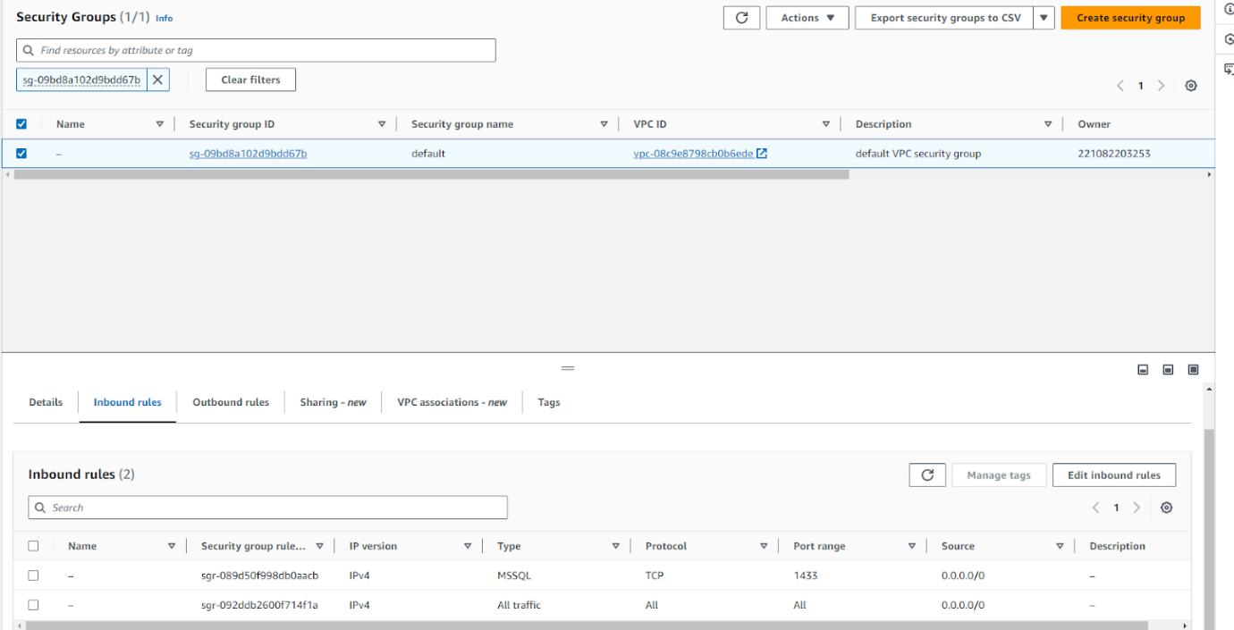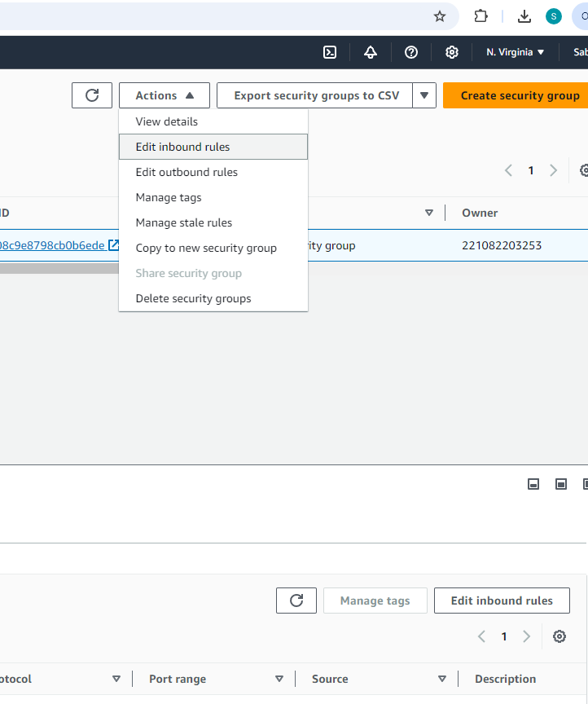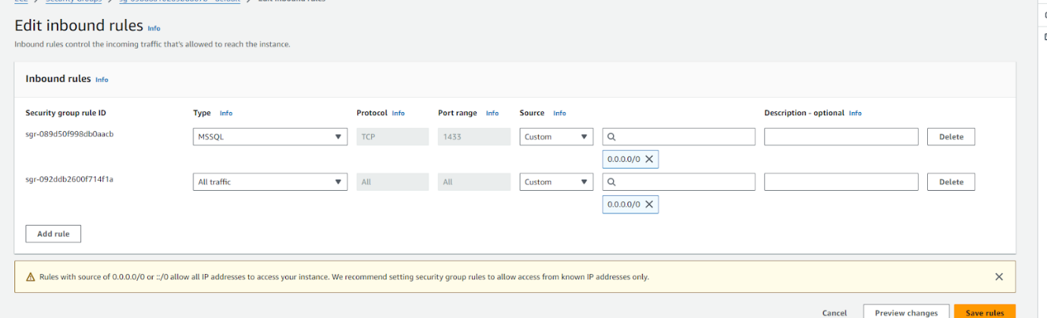

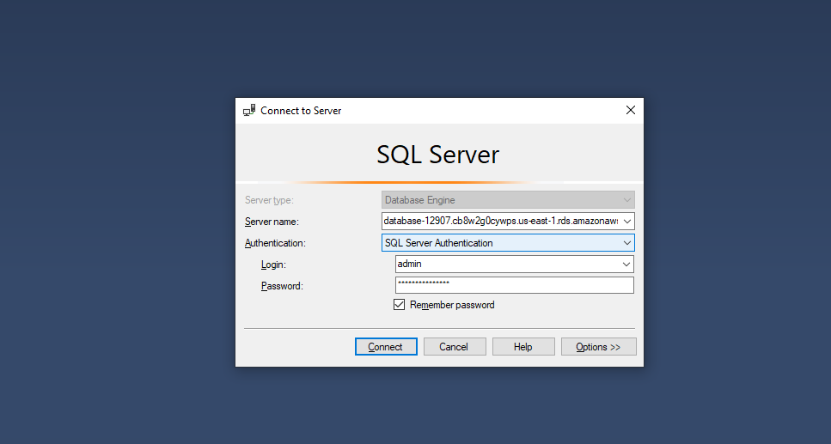

**Swagger API Description**

**Books table**

Description: Retrieves all book records from the database.

Endpoint: GET /api/Books

Return: List of all books in the database



**GetBook**

**Description**: Retrieves a single book by ID.

**Endpoint**: GET /api/Books/{id}

**Parameters**: id (int)

**Return**: A single book object if found; otherwise, returns 404 Not Found.



Description: Adds a new book record to the database.

Endpoint: POST /api/Books

Parameters: book (Book object) - the book data to add.

Return: The created book record, along with a 201 Created status.







PutBook

* Description: Updates an existing book record identified by its ID.
* Endpoint: PUT /api/Books/{id}
* Parameters:
  + id- the unique identifier of the book to update.
  + book - the updated book data.
* Return: 204 No Content if successful; 400 Bad Request if the id in the request does not match the book's ID; 404 Not Found if the book does not exist.

DeleteBook ([HttpDelete("{id}")]):

* Description: Deletes a book record from the database by its ID.
* Endpoint: DELETE /api/Books/{id}
* Parameters: id (int) - the unique identifier of the book to delete.
* Return: 204 No Content if the book was deleted; 404 Not Found if the book does not exist.



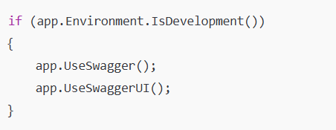

This enables Swagger UI for effective documentation, making it easier to test and visualize the API endpoints.







**Diagrams**

**Gantt Chart**

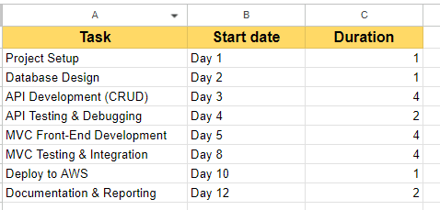

#### System Architecture Diagram

* Frontend (MVC Application): Handles user interface for CRUD operations.
* Backend (API): ASP.NET Core Web API that performs CRUD operations and interacts with the database.
* Database: SQL Server database hosted on AWS RDS.
* Deployment: AWS EC2 instances for API and MVC application.

#### Sequence Diagram

* Flow of a typical CRUD operation:
  1. **Create Operation**: User requests to create a book -> MVC sends data to API -> API validates and saves to database -> Success response to MVC -> Confirmation to User.
* This can be repeated for Read, Update, and Delete operations to illustrate end-to-end data flow.

#### Component Diagram

* Main components of the application:
  + **User Interface (MVC)**, **API Layer**, and **Database**.
* Each component is a module that communicates with the others via HTTP requests or database calls.

**Screenshots with Version Information**

**LibraryAPI**

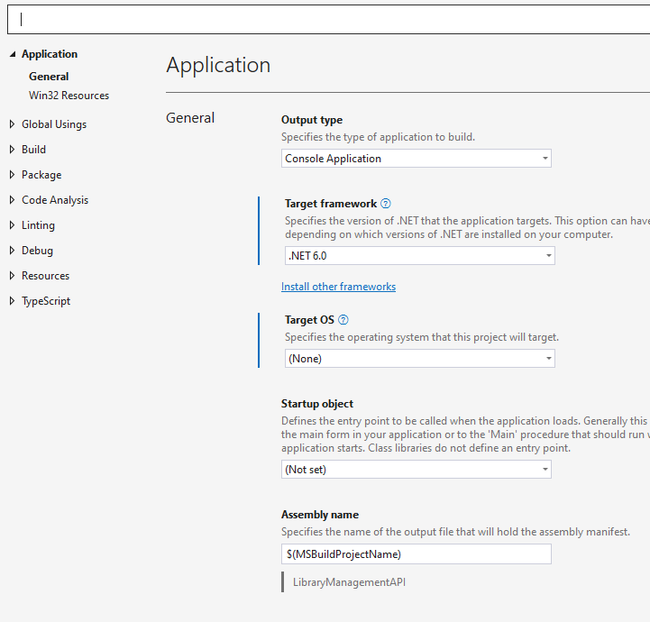

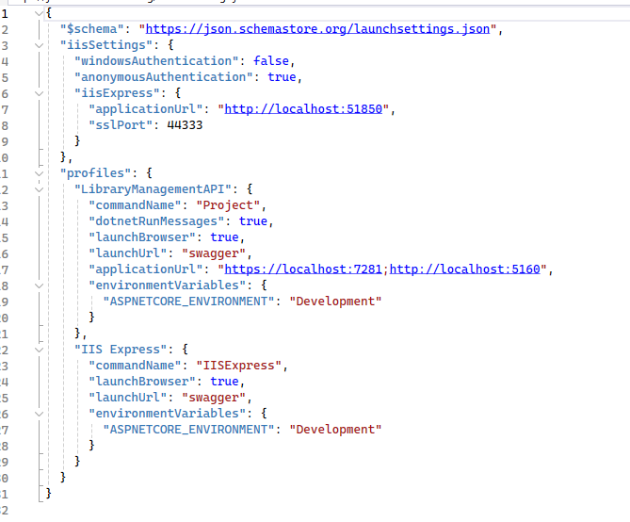

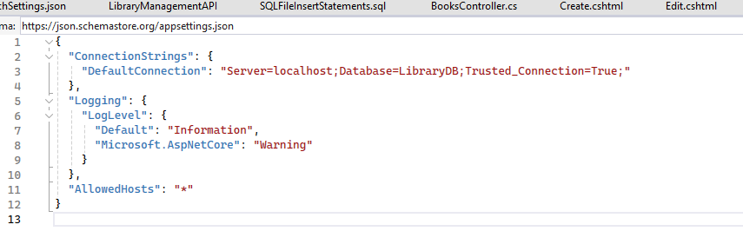

**Packages**

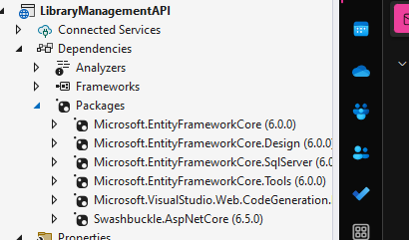

**LibraryMVC**

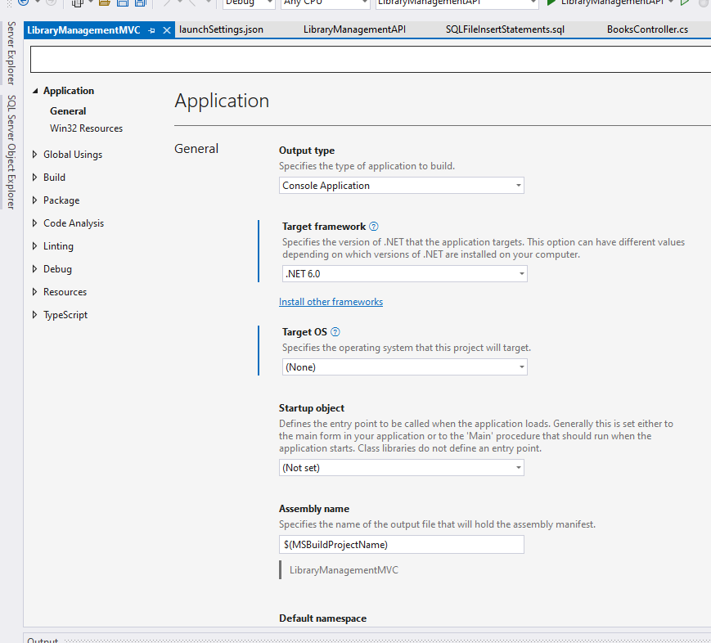

**Packages**

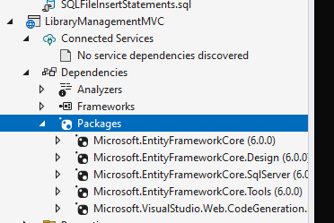

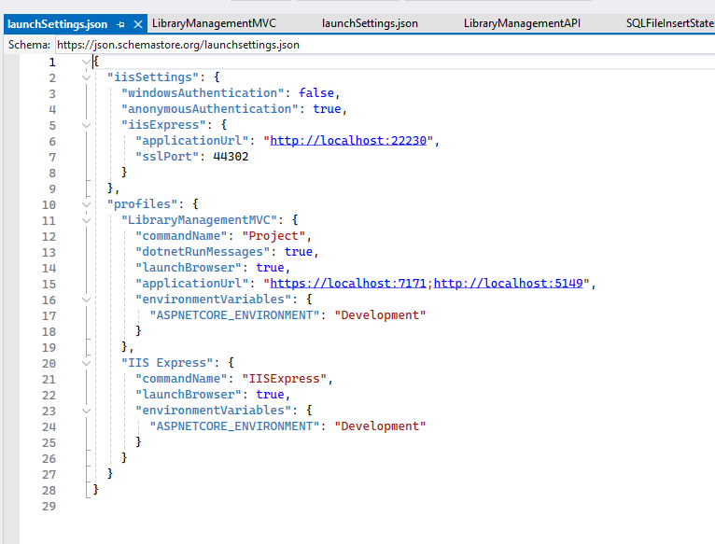

**Database Migrations**

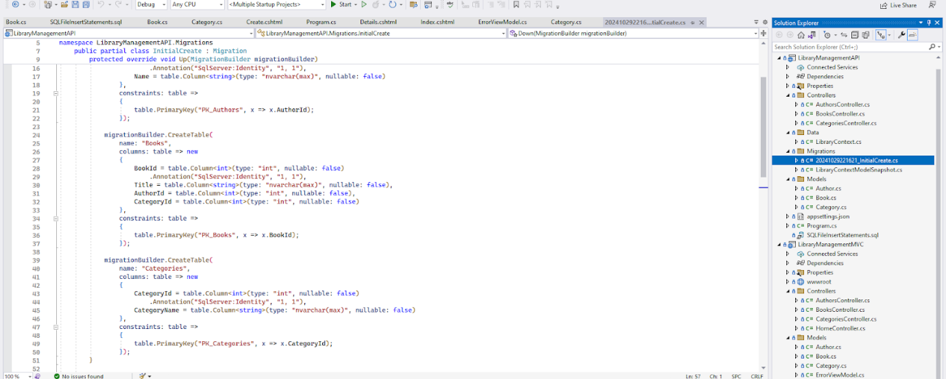

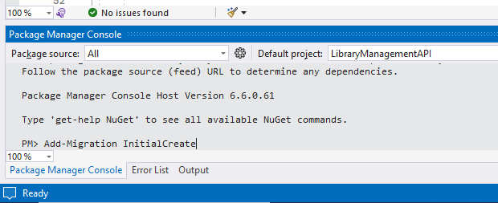

**Stand-alone SQL File with Insert Statements**

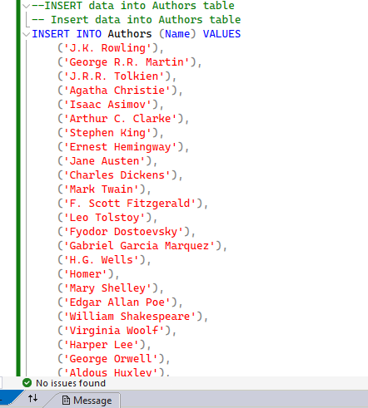

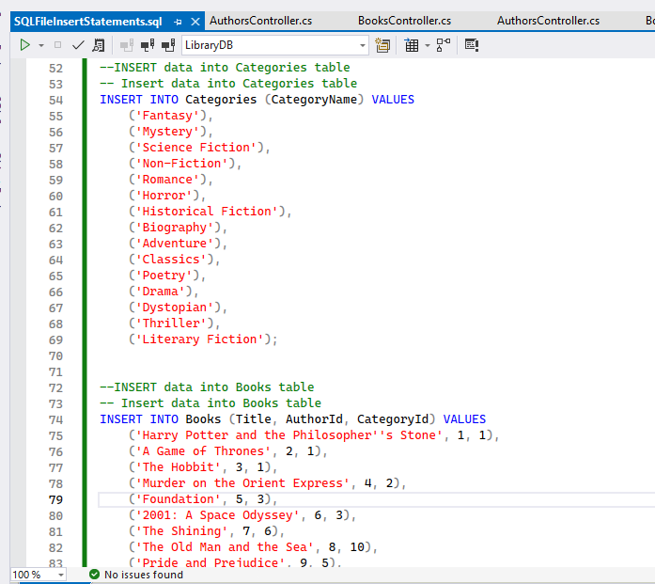

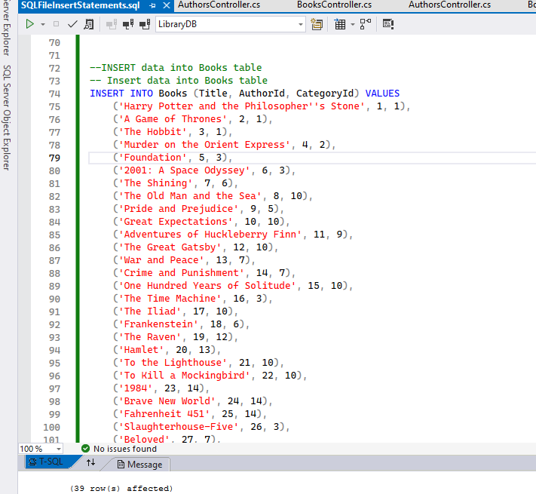

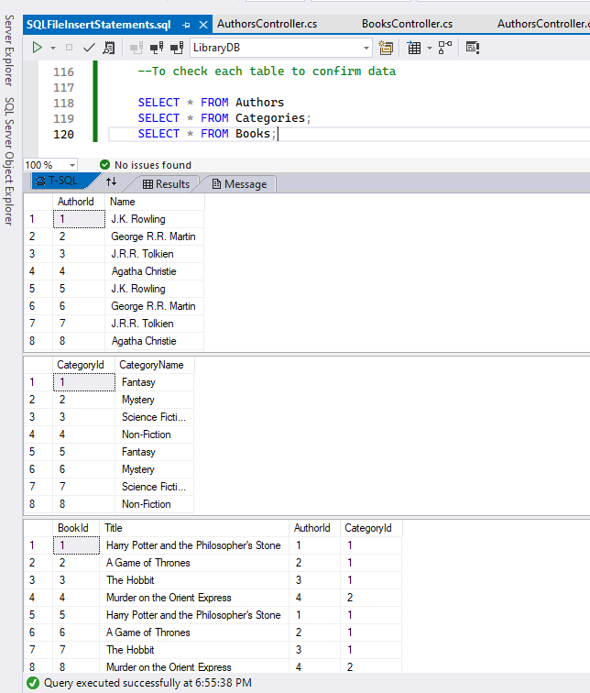

**Database Structure Diagram**

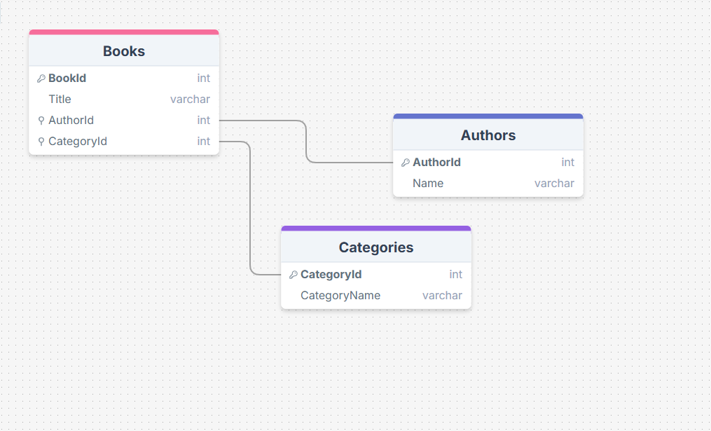

<https://drawsql.app/teams/sabrina-2/diagrams/dscc-12907-librarydb>

**Key Relationships**:

* Books.AuthorId → Authors.AuthorId
* Books.CategoryId → Categories.CategoryId

**Github**

[*https://github.com/Pheobee/LibraryManagementAPI_12907.git*](https://github.com/Pheobee/LibraryManagementAPI_12907.git)

<https://github.com/Pheobee/CodeDeployGuthubbDemo.git> - CodeDeploy

**Initial repository creation**

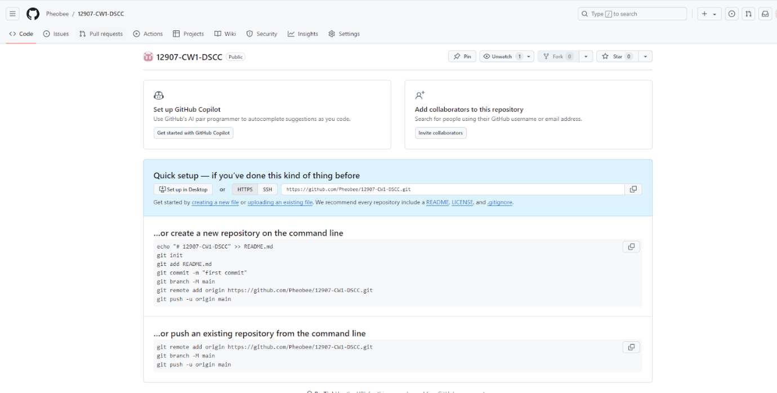

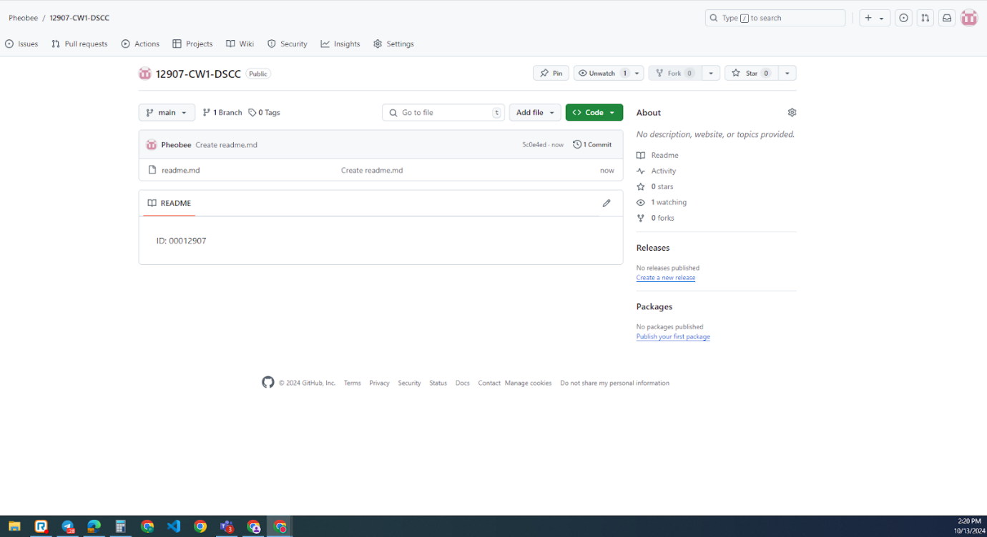

**Pushing the changes into the repo**

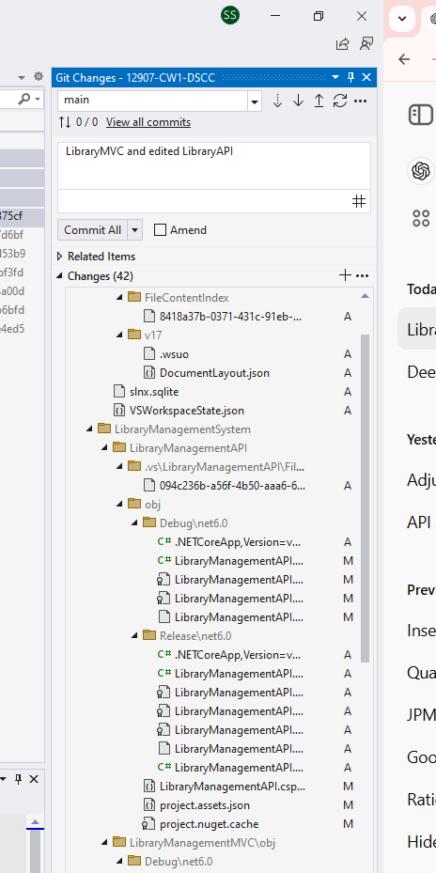

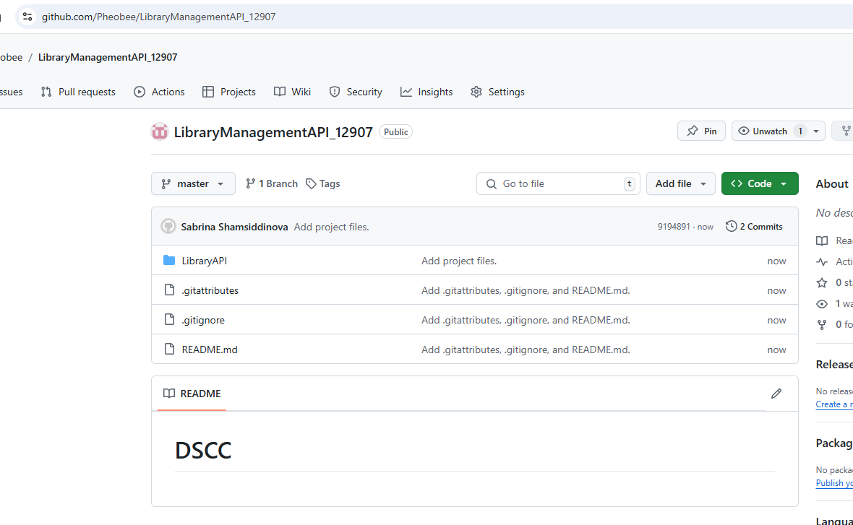

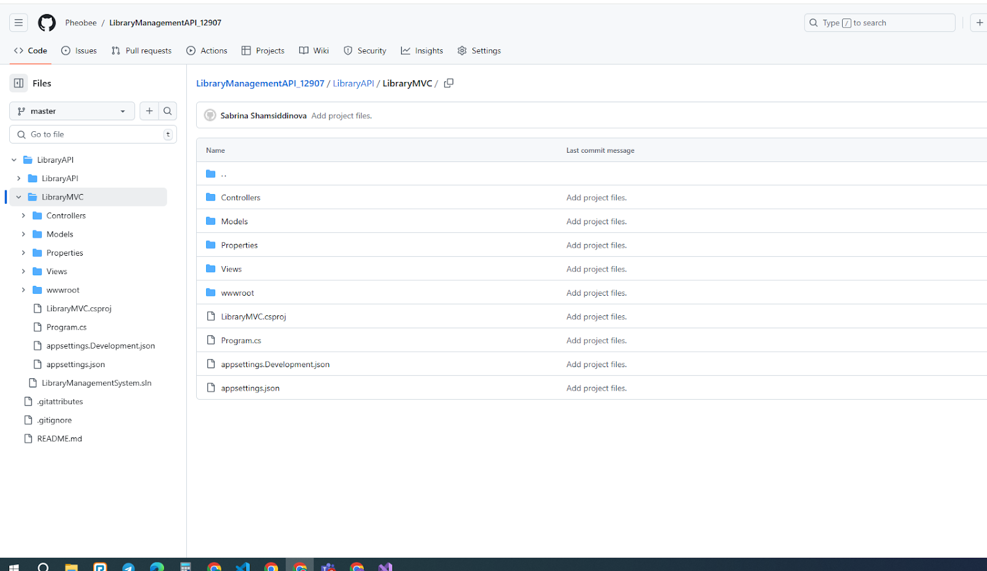

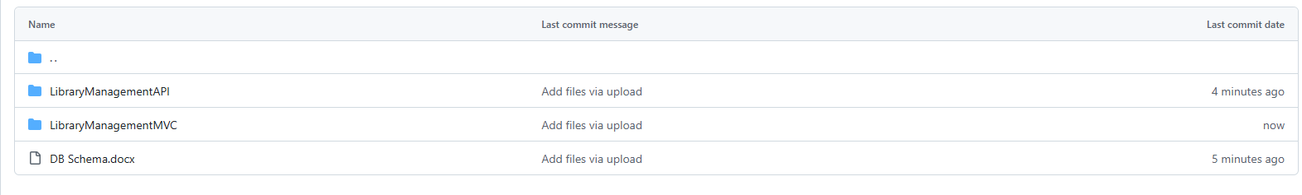

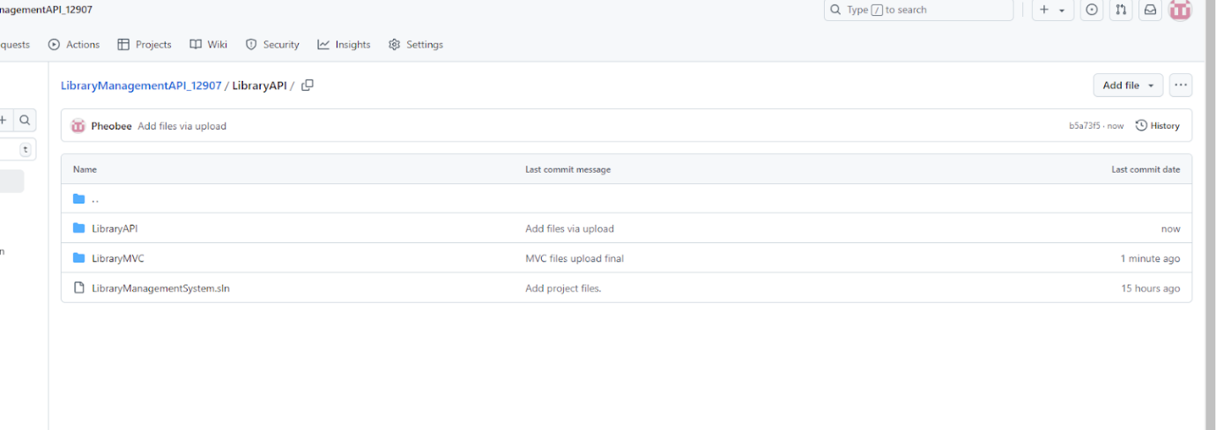

*Commits were made during two week period, however at the end of the final submission, I had to create another repository for deployment and made changes to the files.*

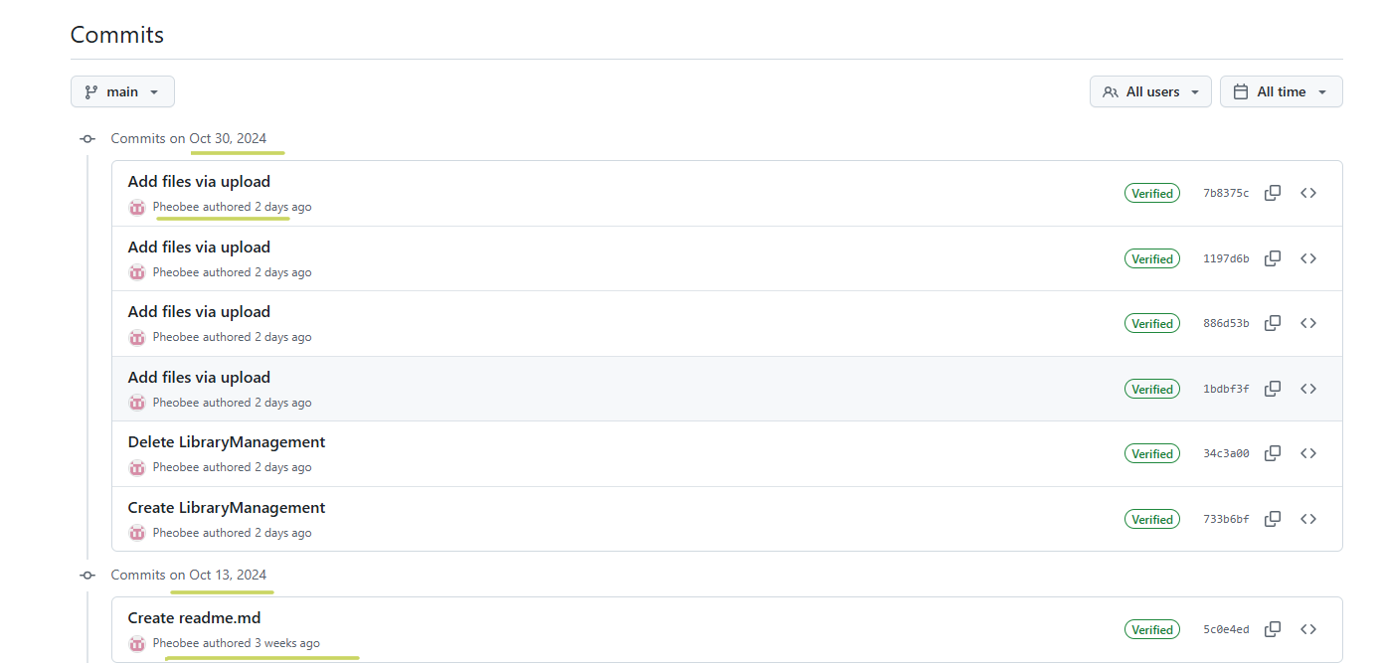

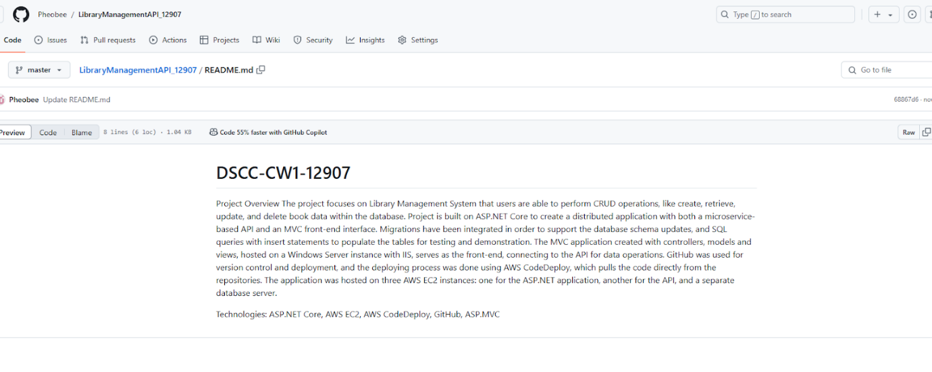

**Hosting and Code Deploy**

**Microservice API**

*database-012907.cb8w2g0cywps.us-east-1.rds.amazonaws.com, 1433*

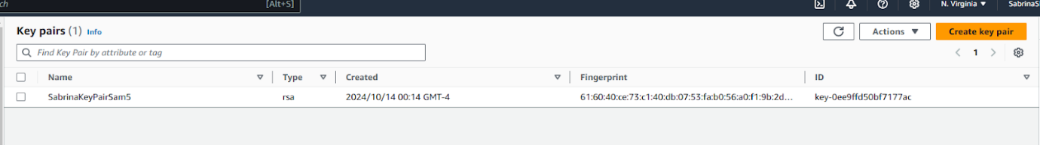

**Instances for Linux and Microsoft Deploy**

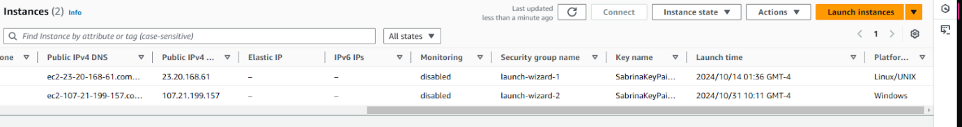

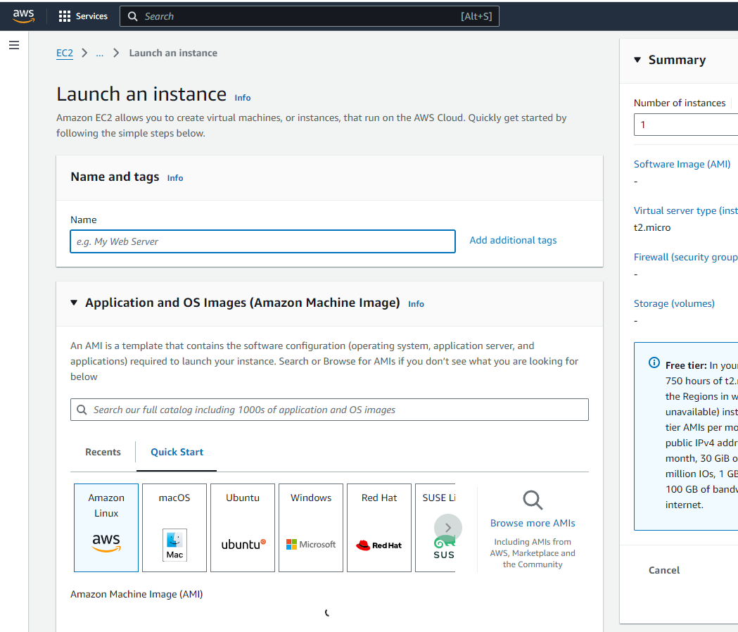

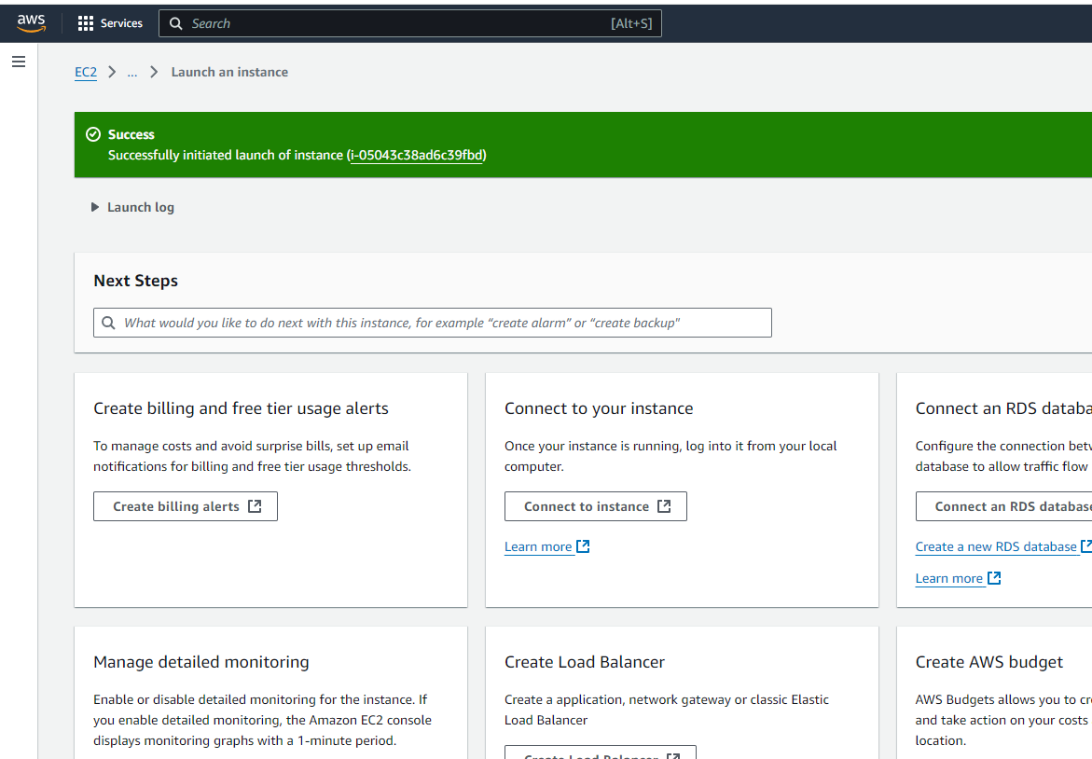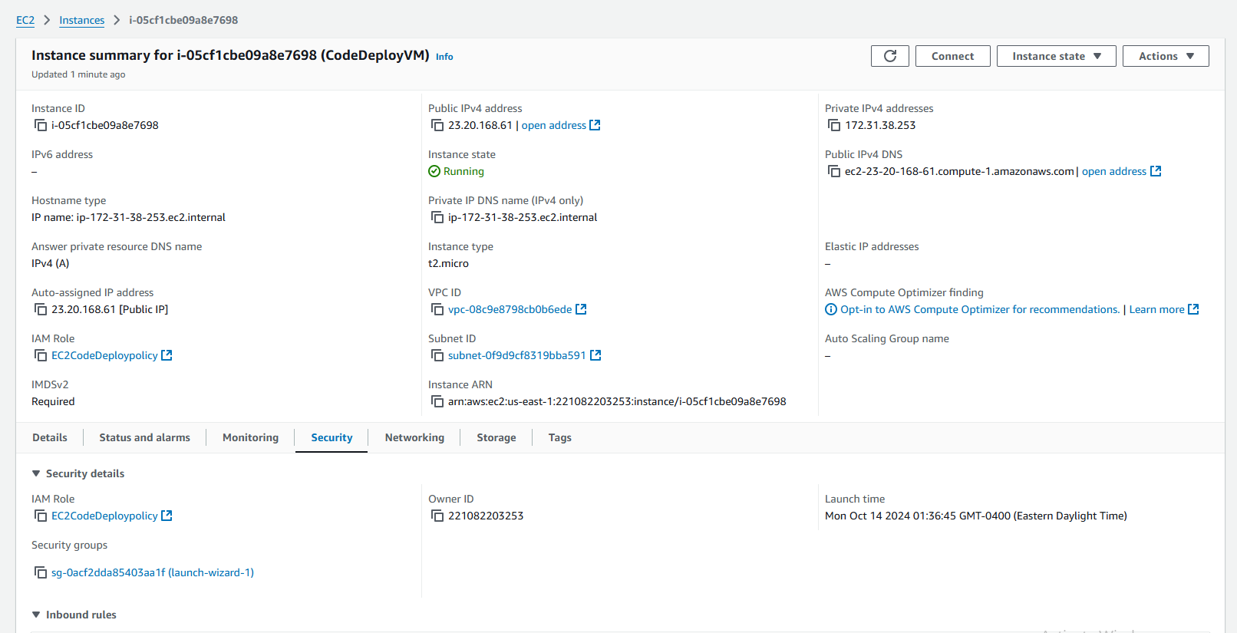

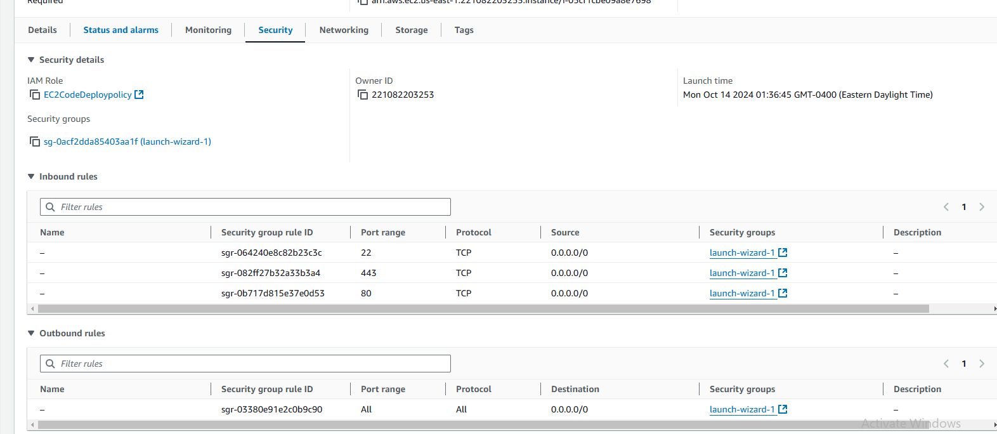

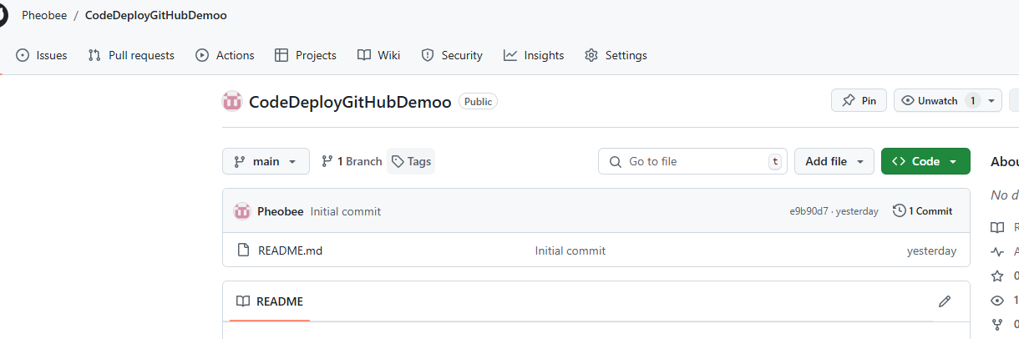

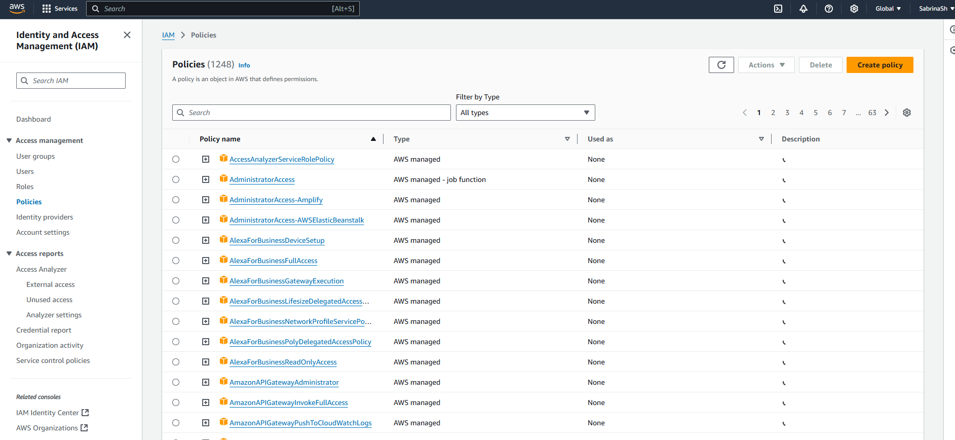

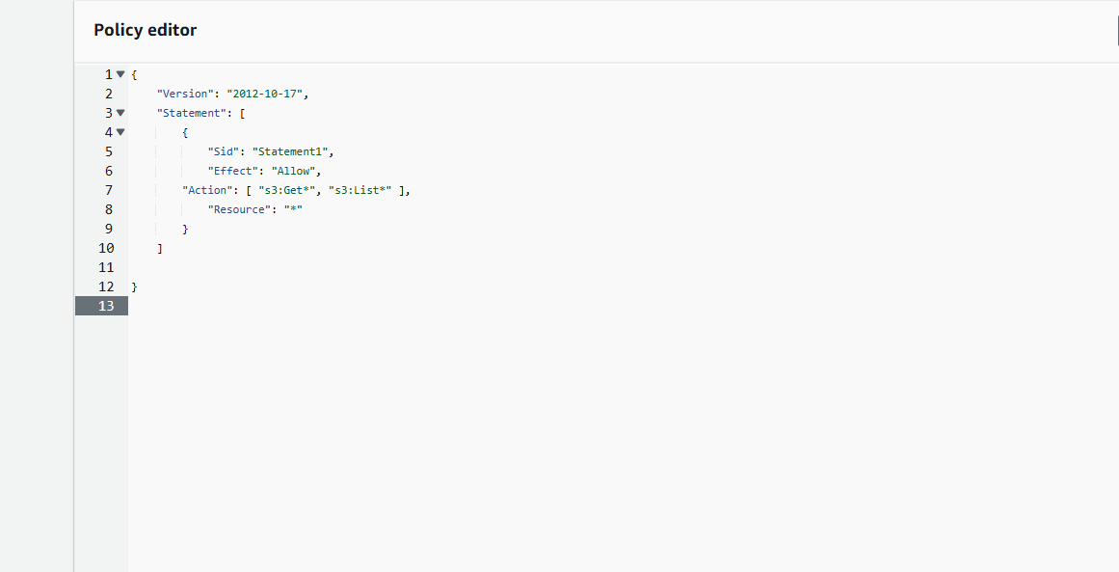

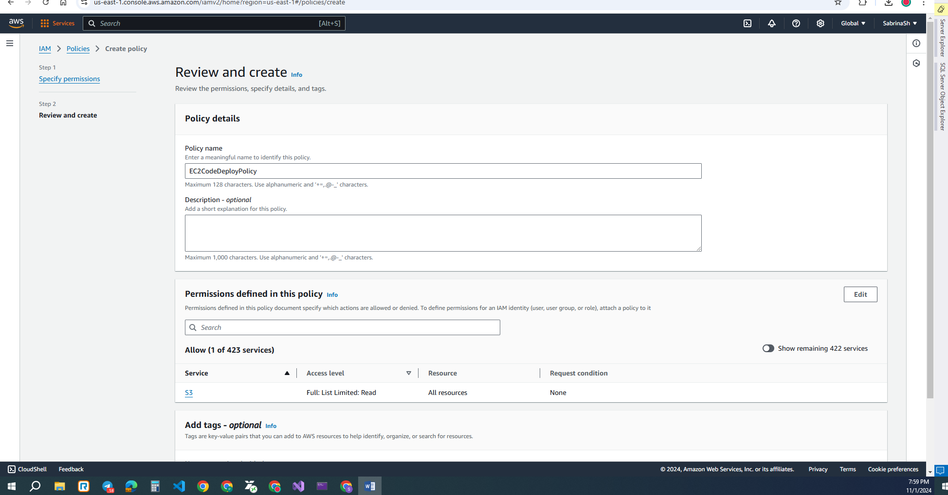

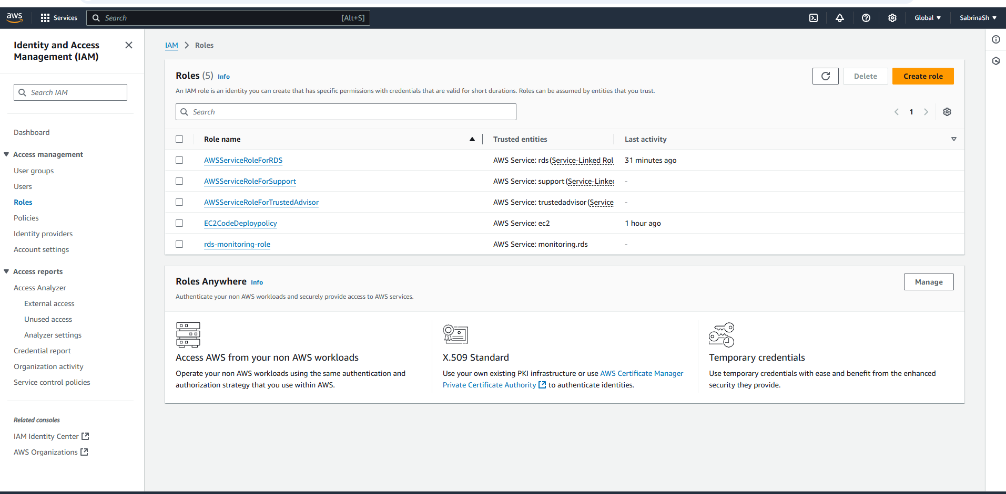

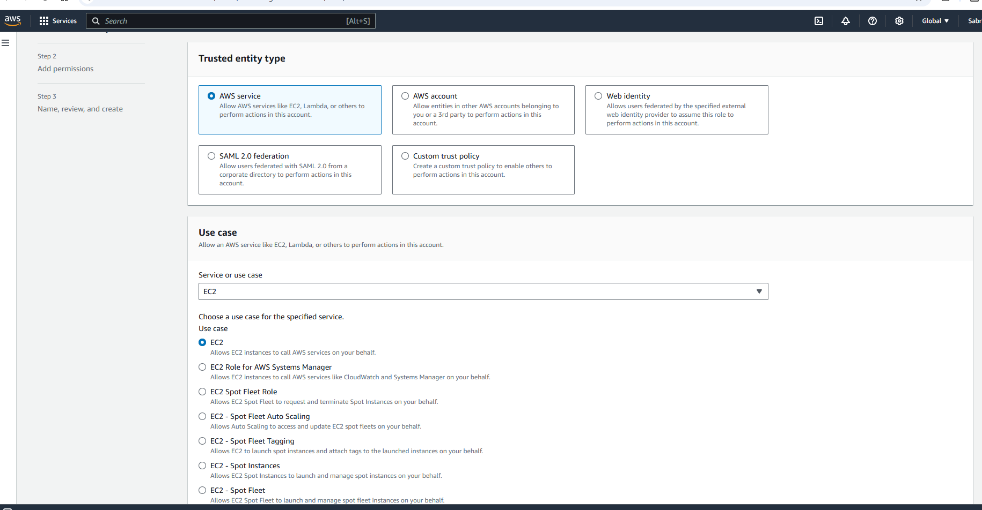

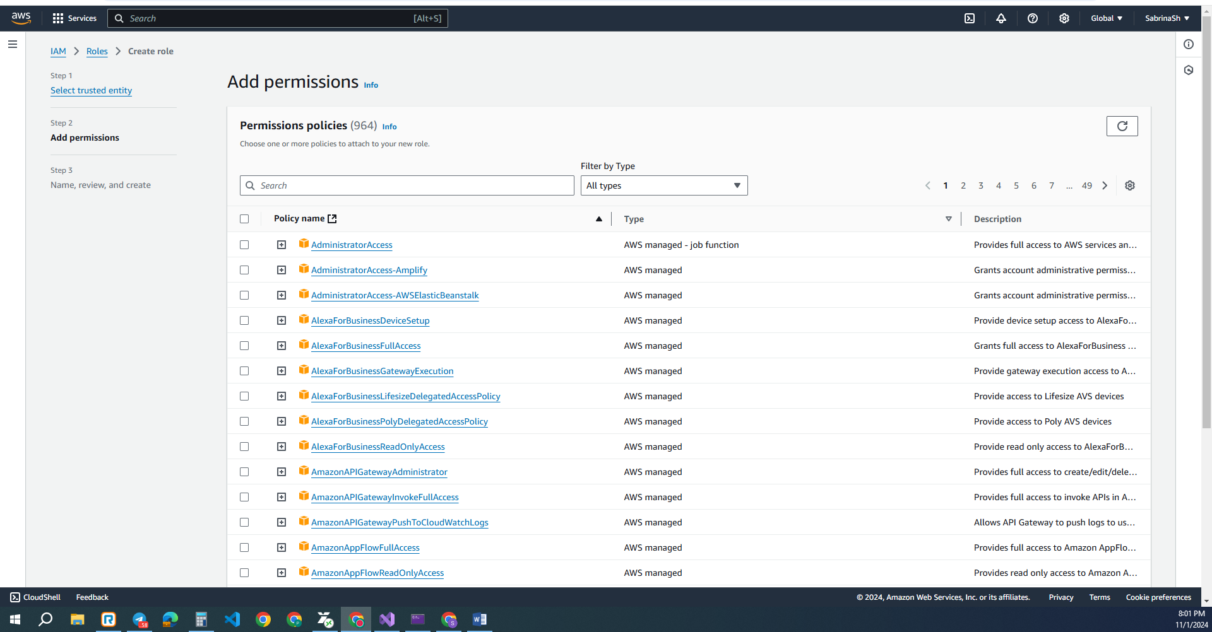

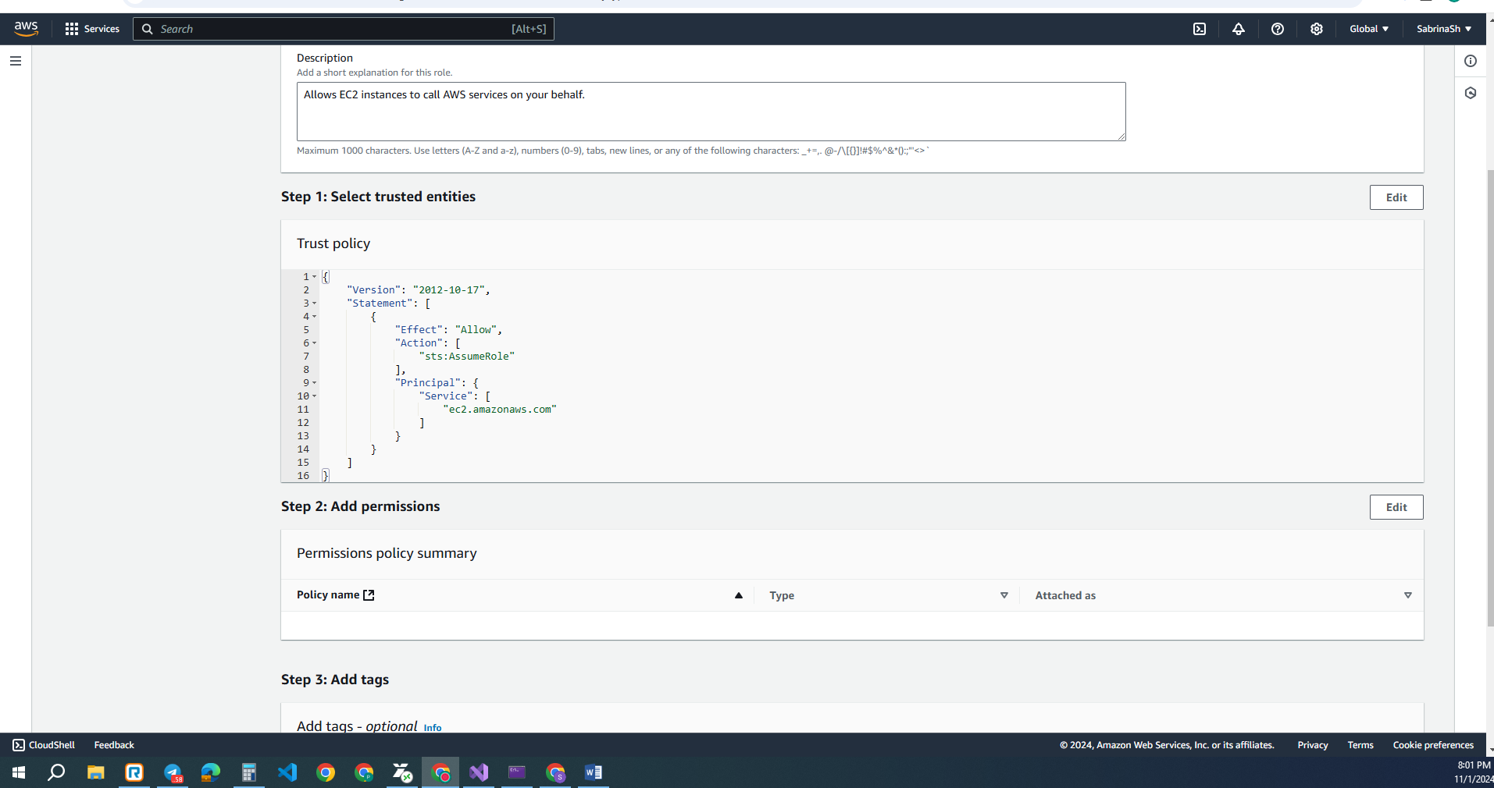

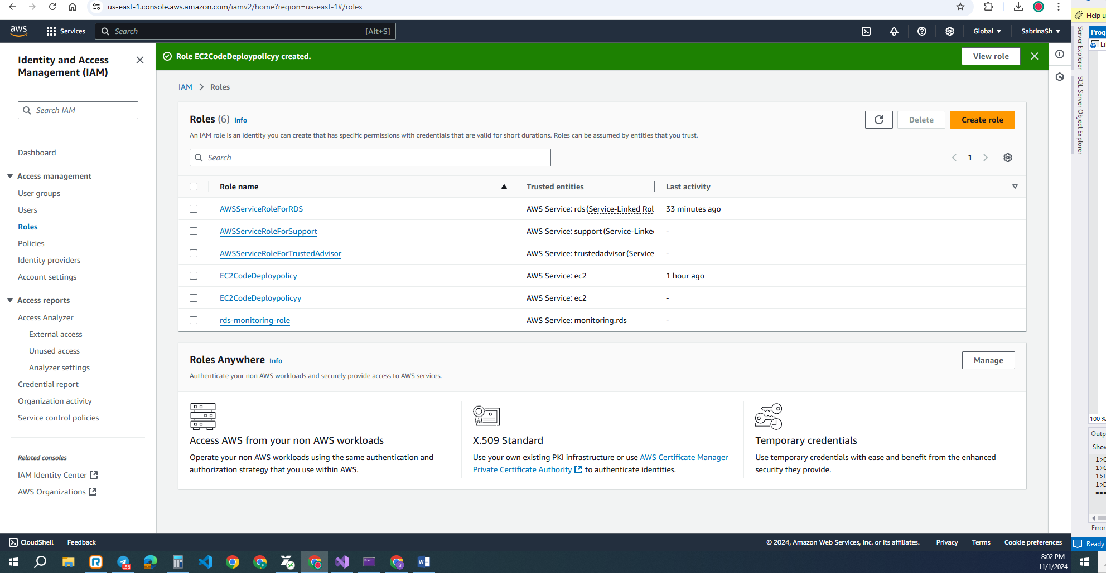

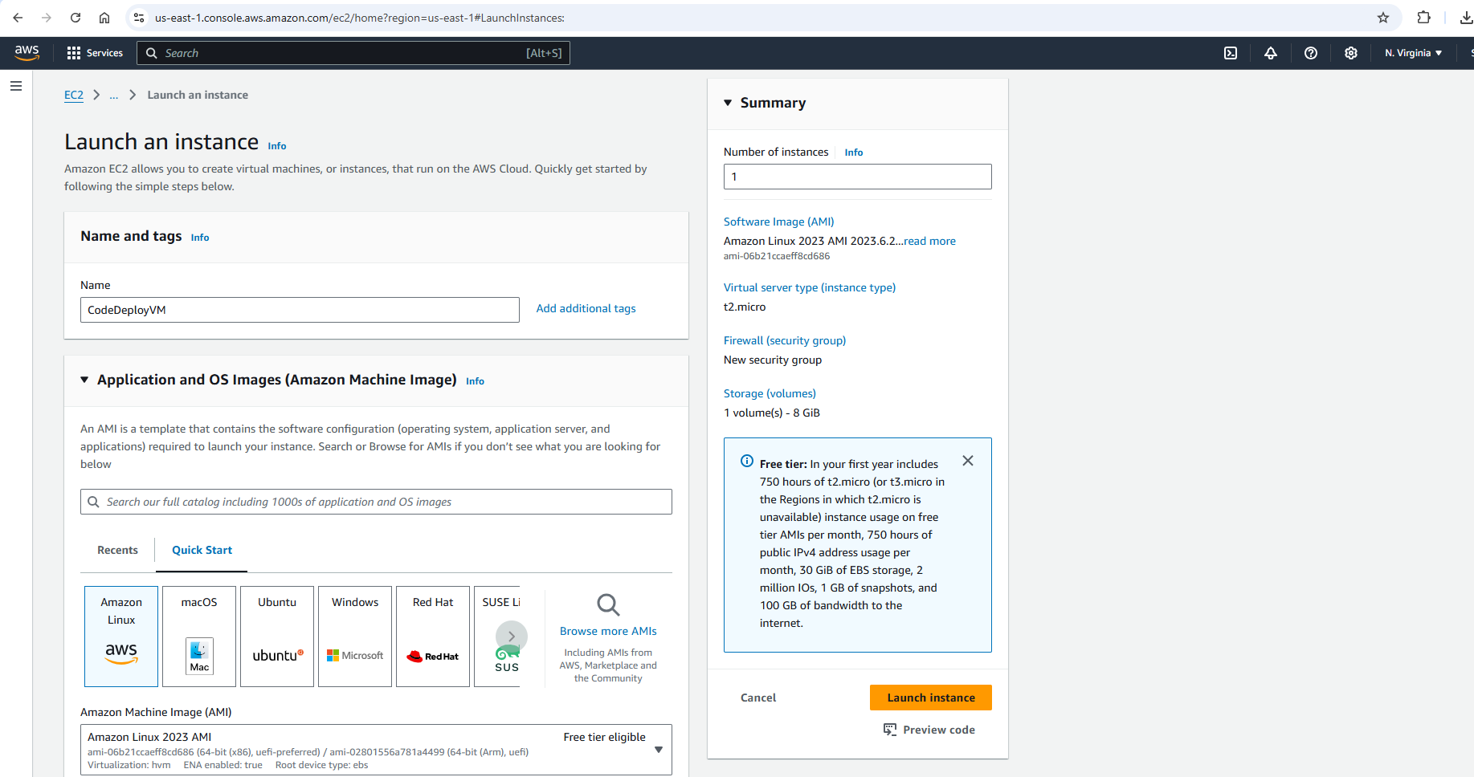

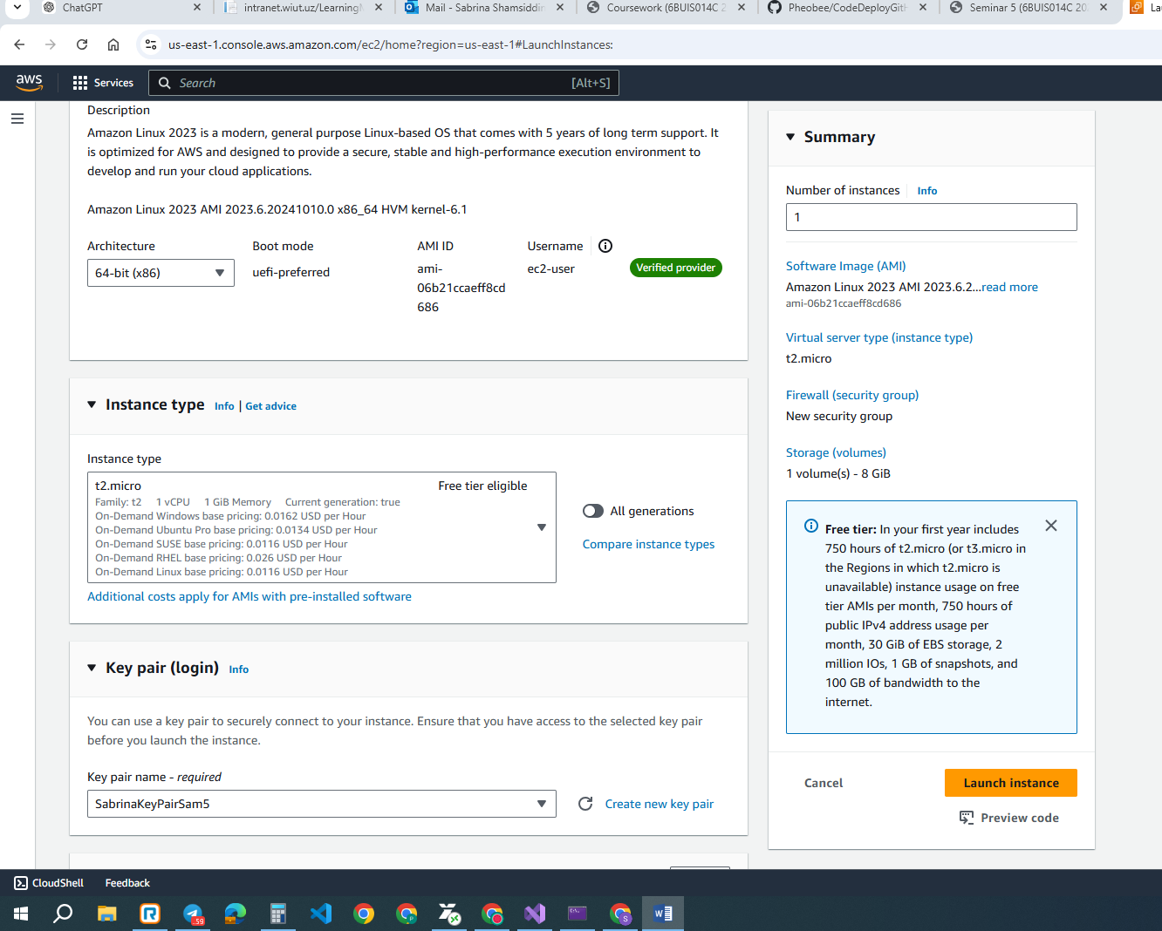

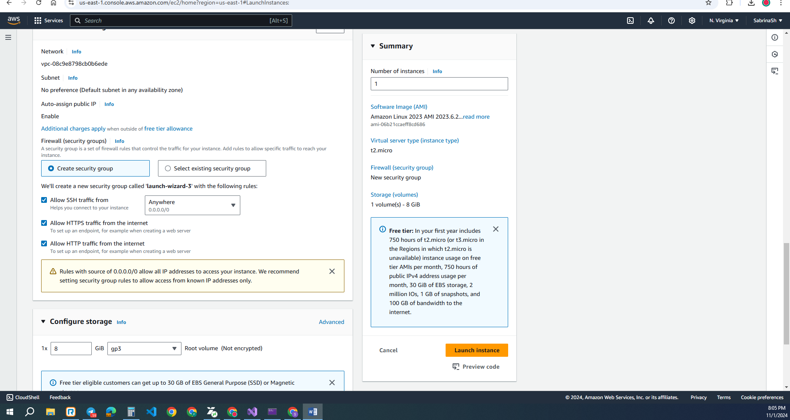

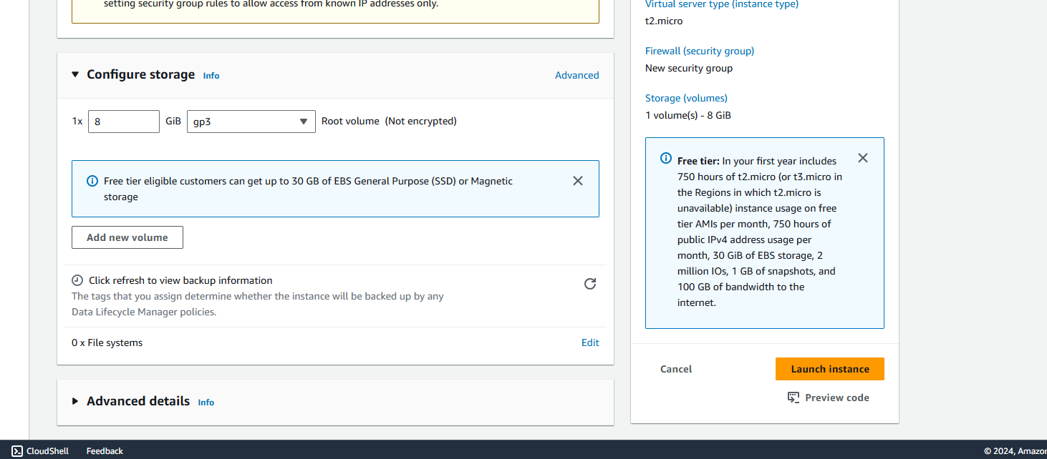

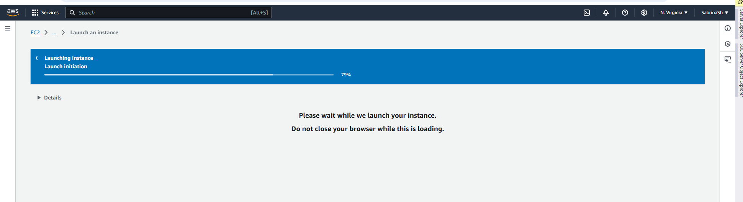

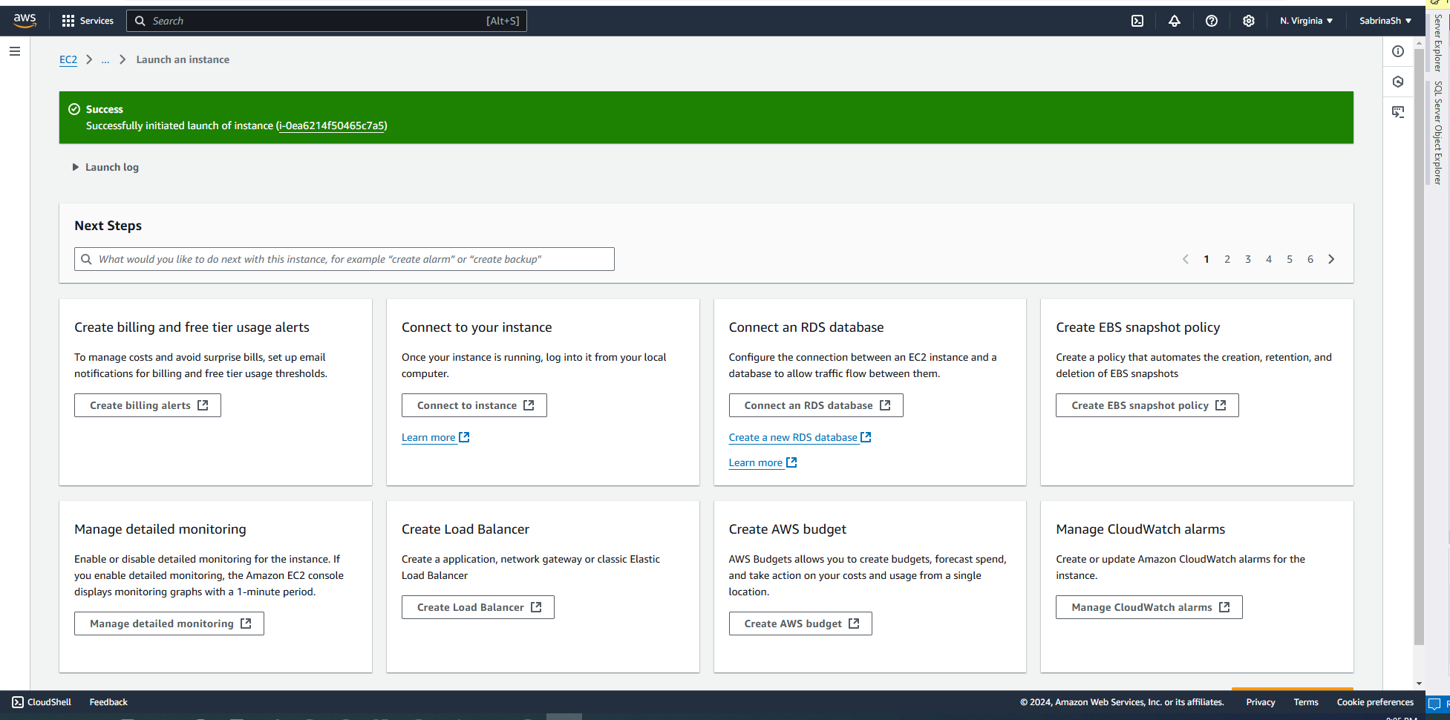

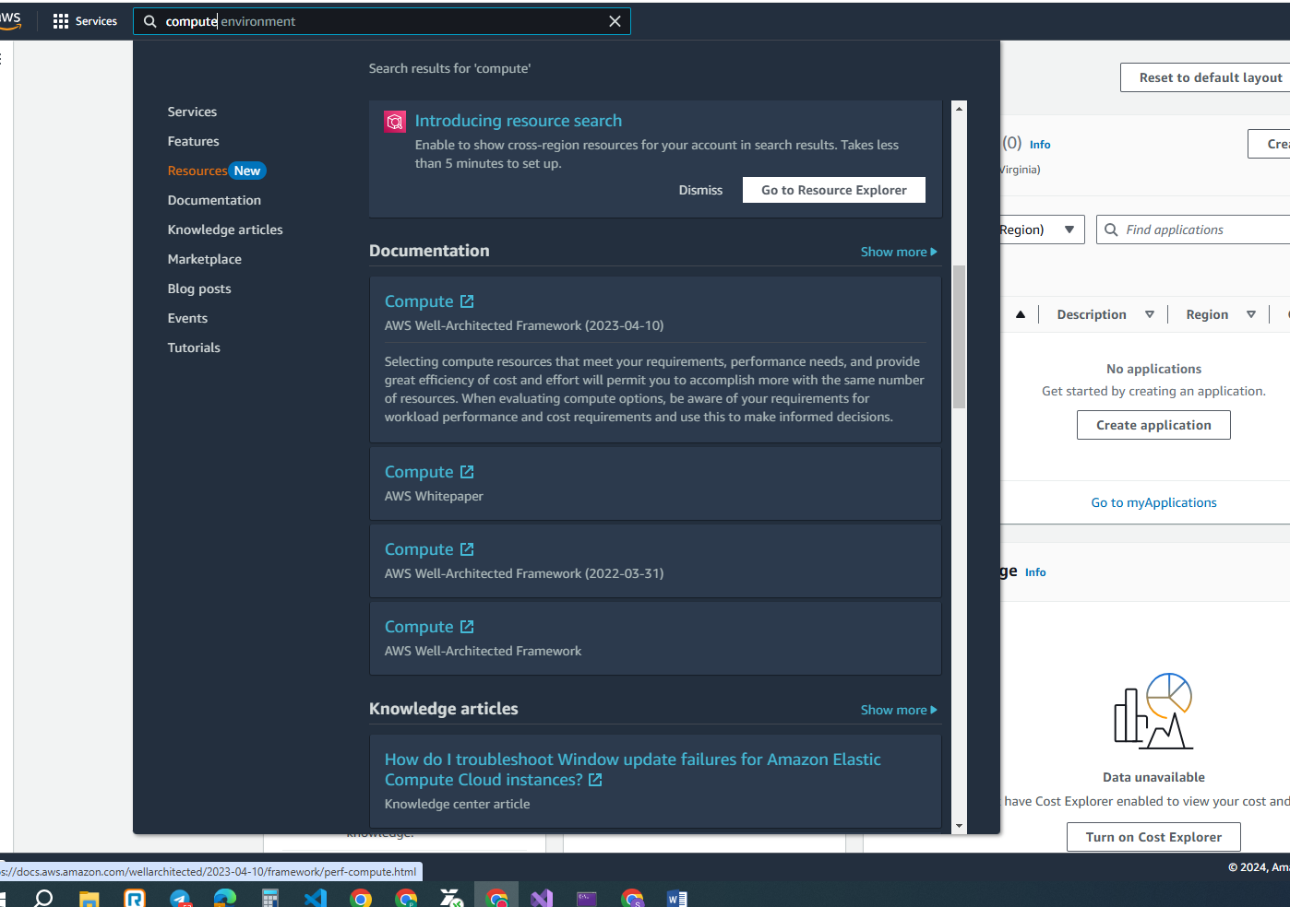

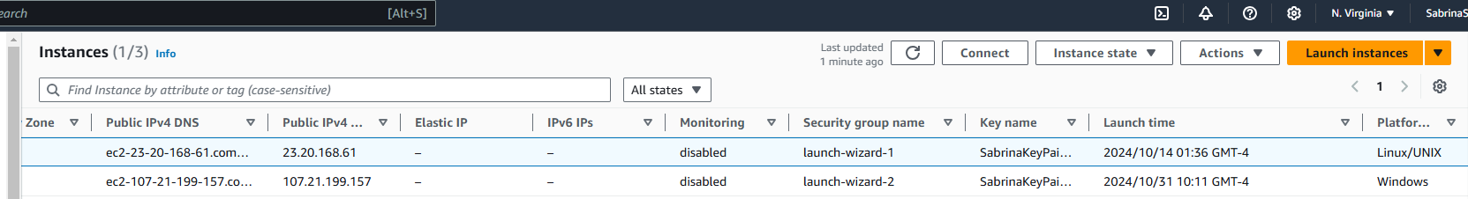

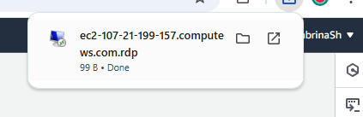

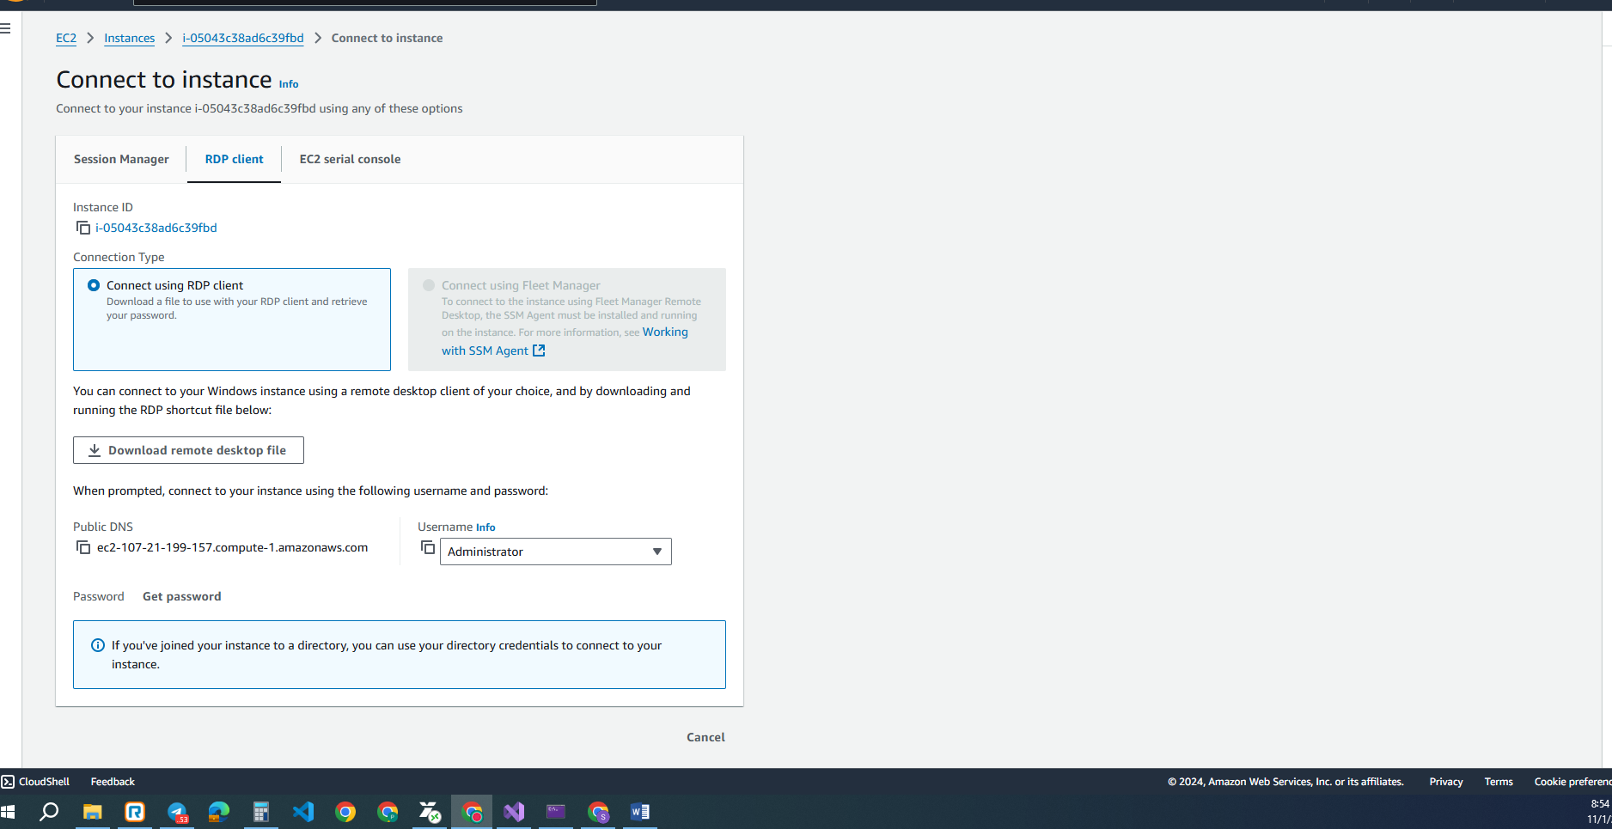

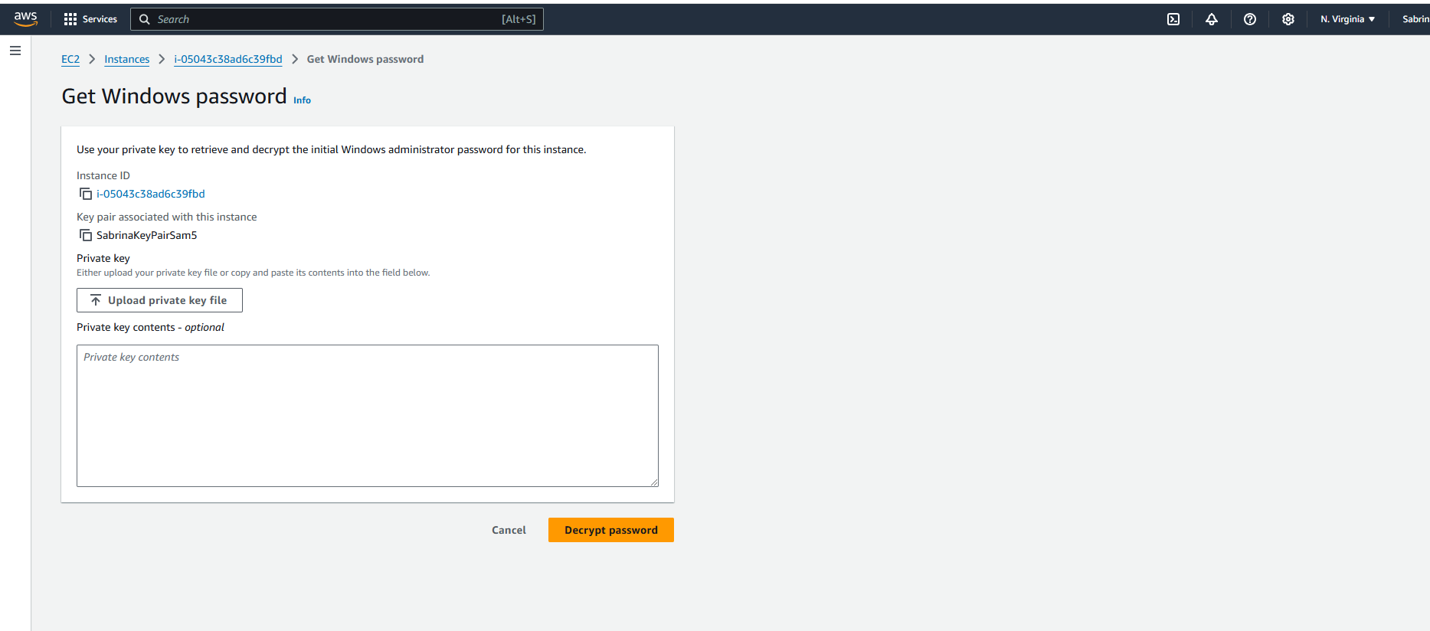

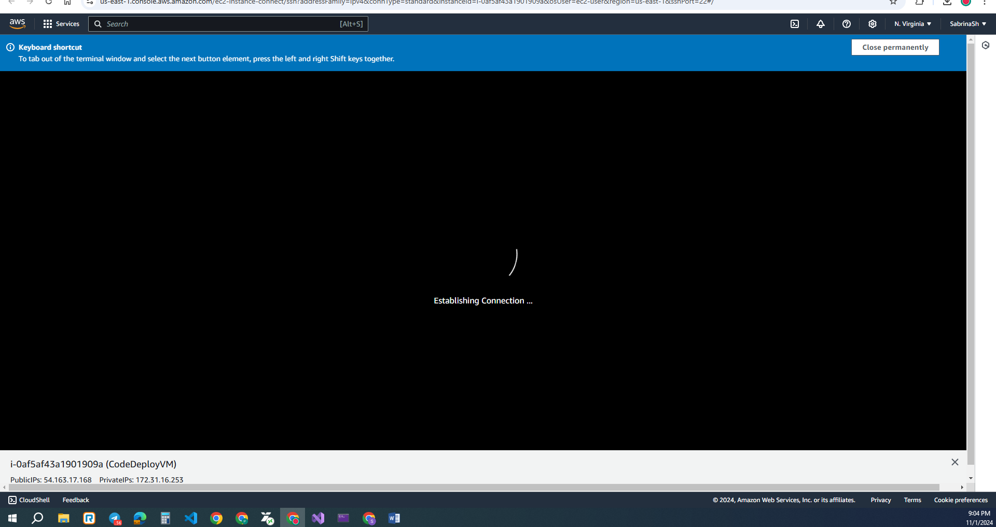

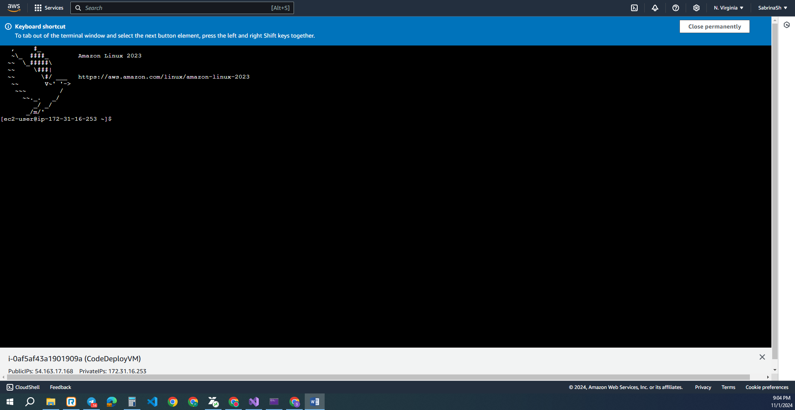

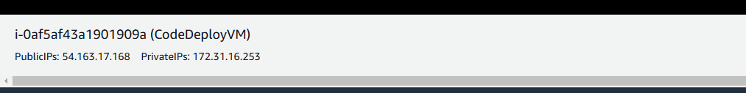

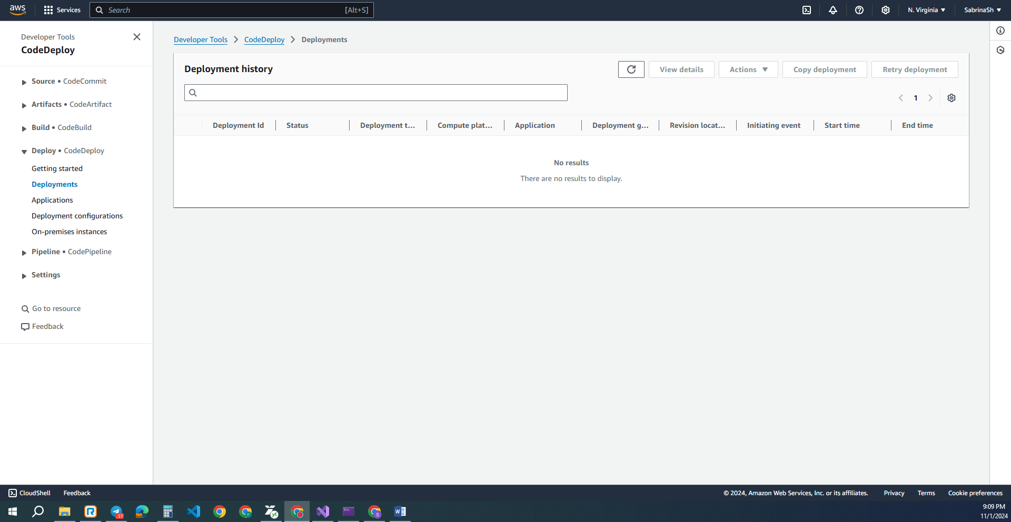

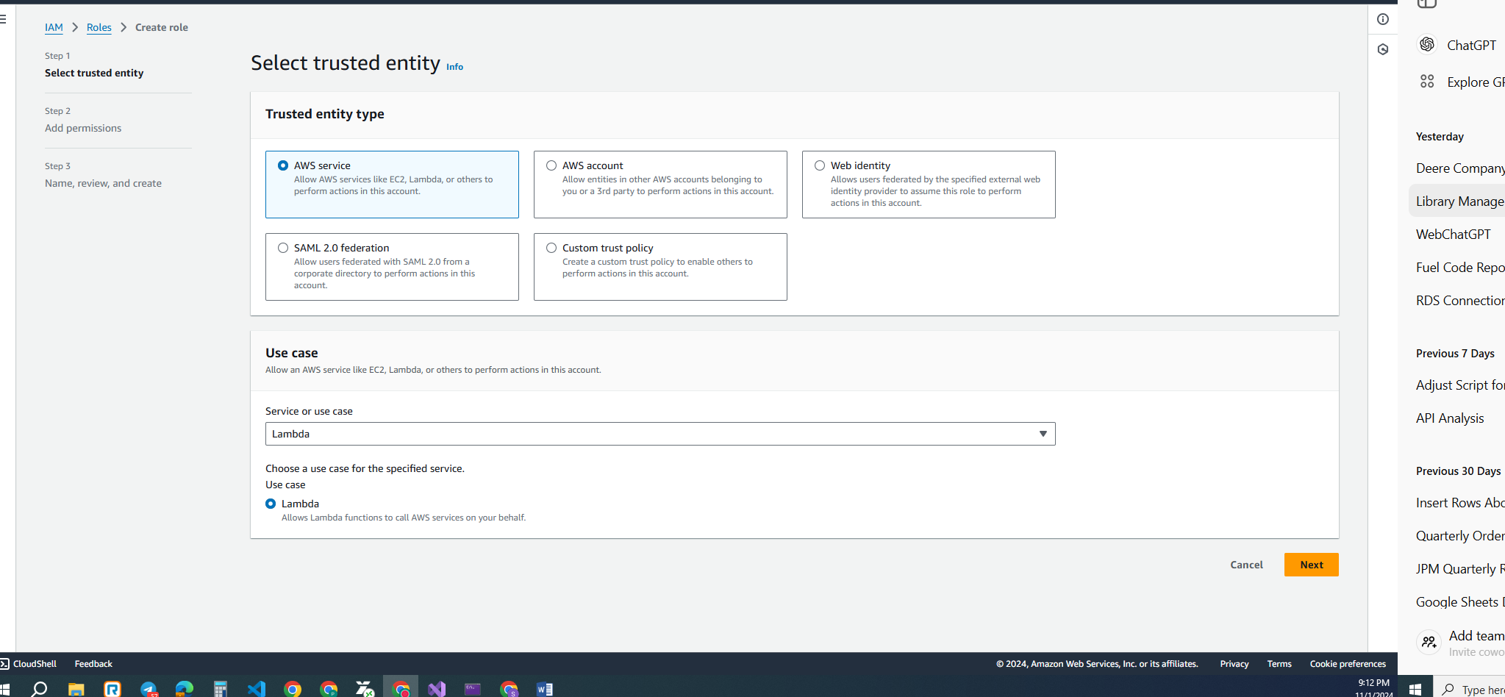

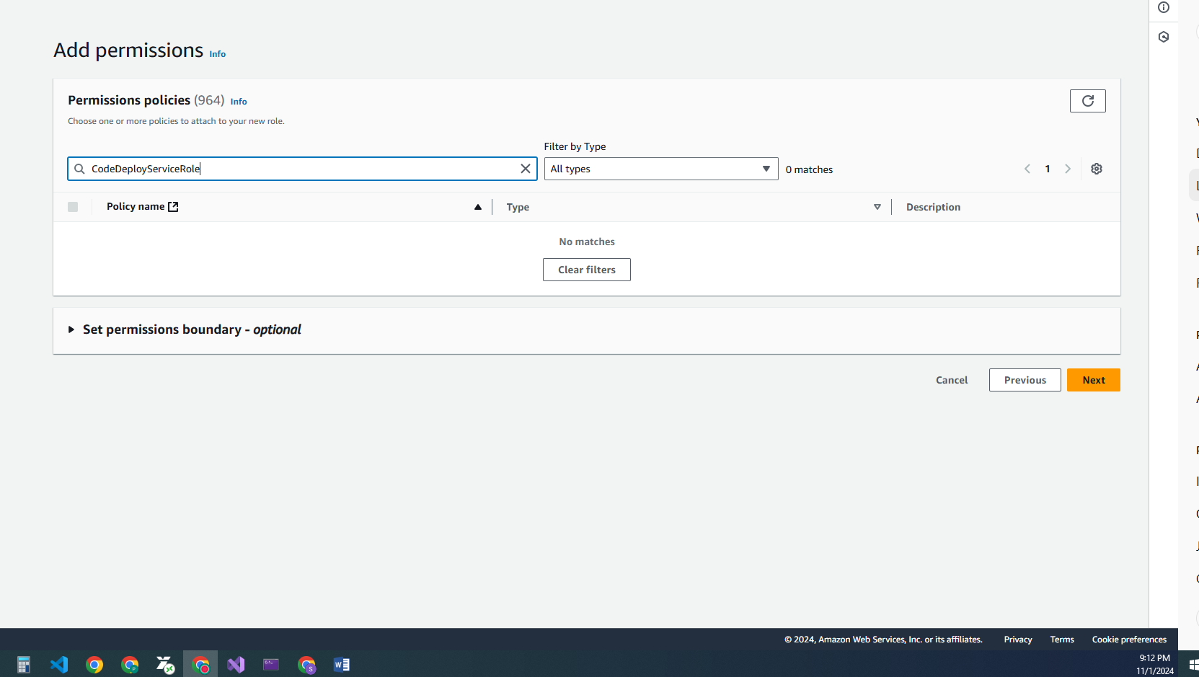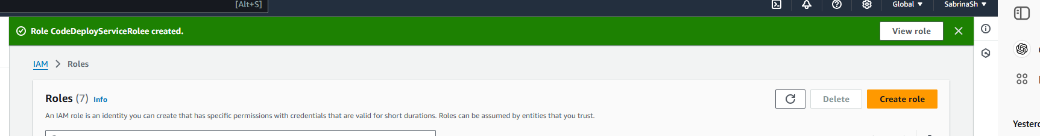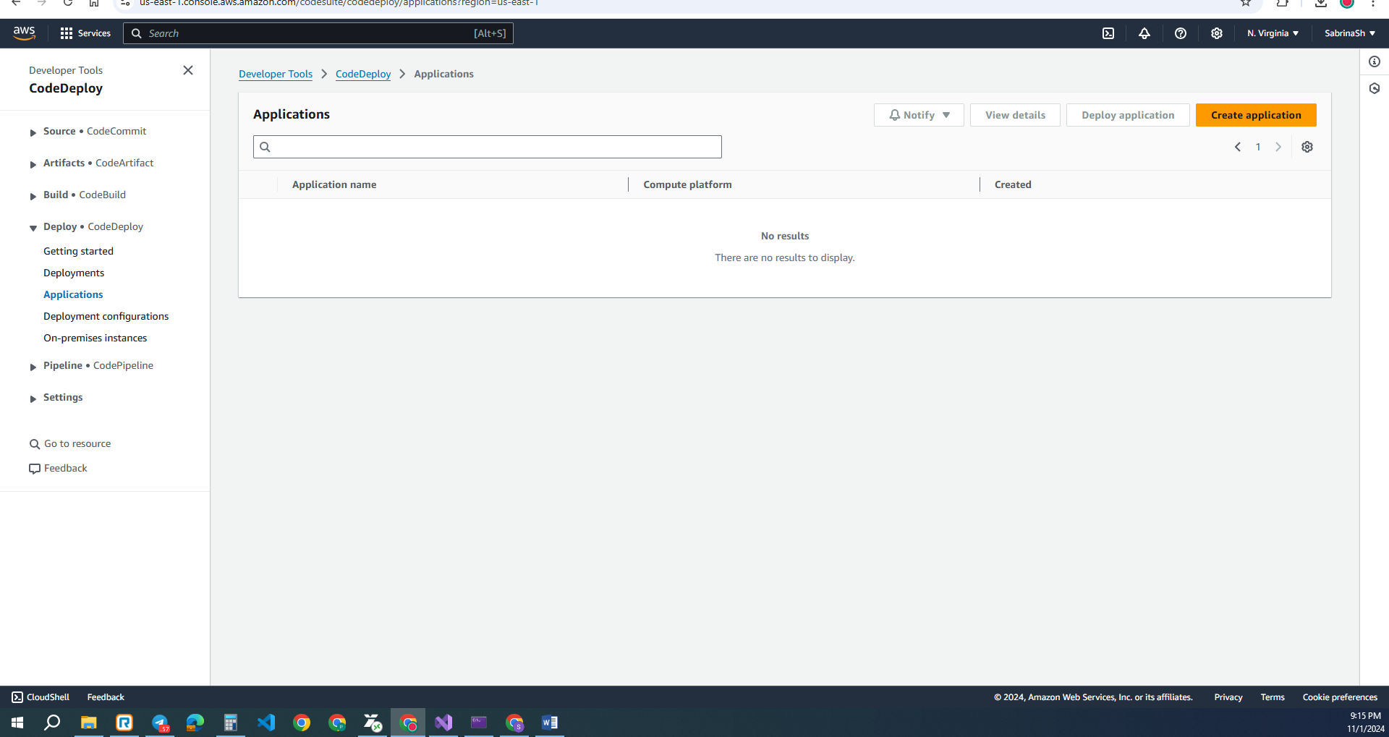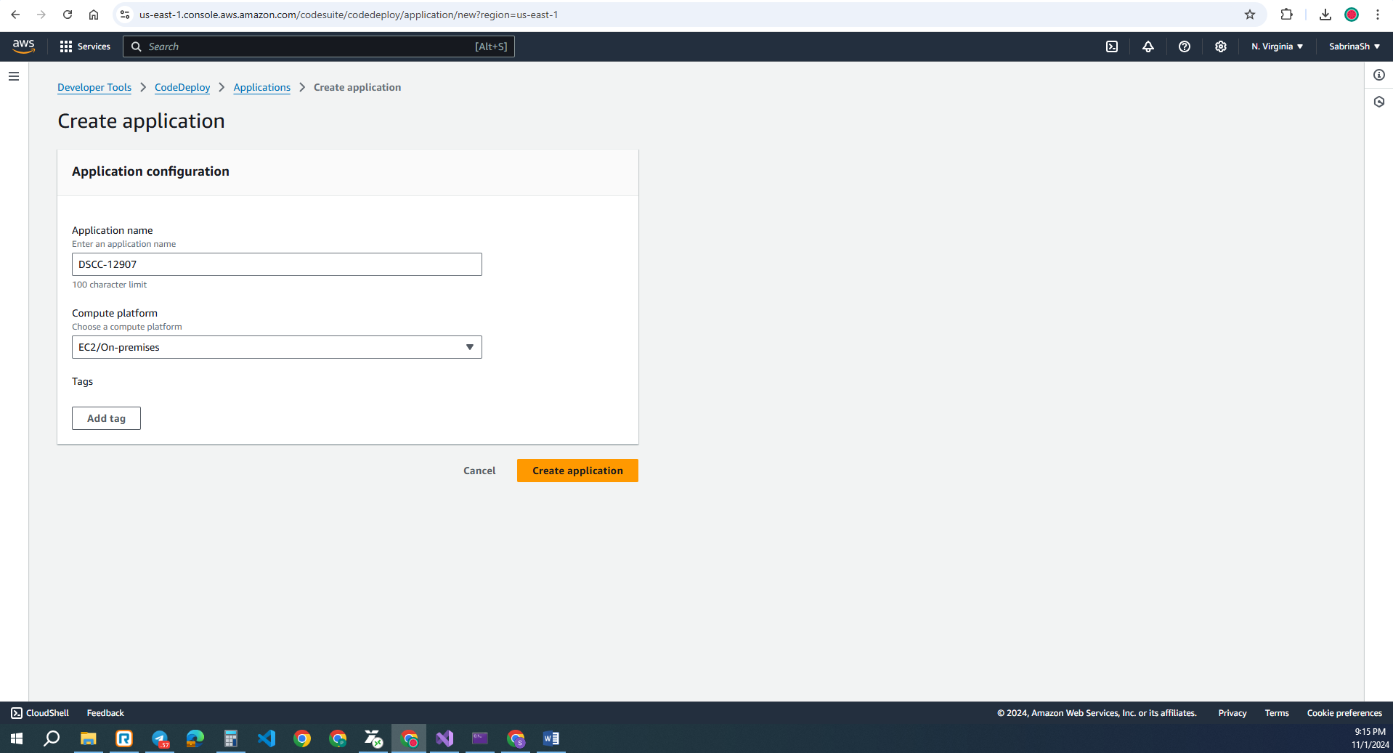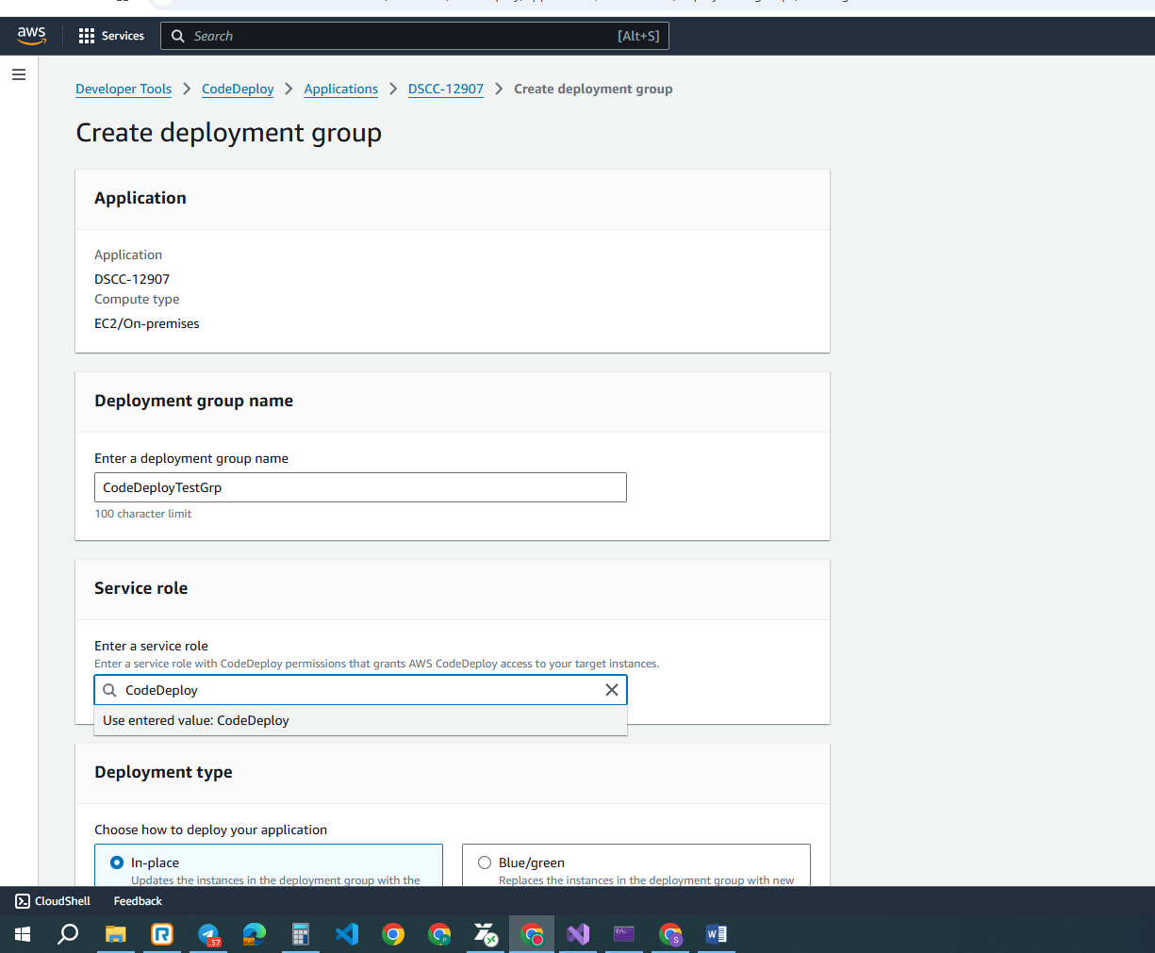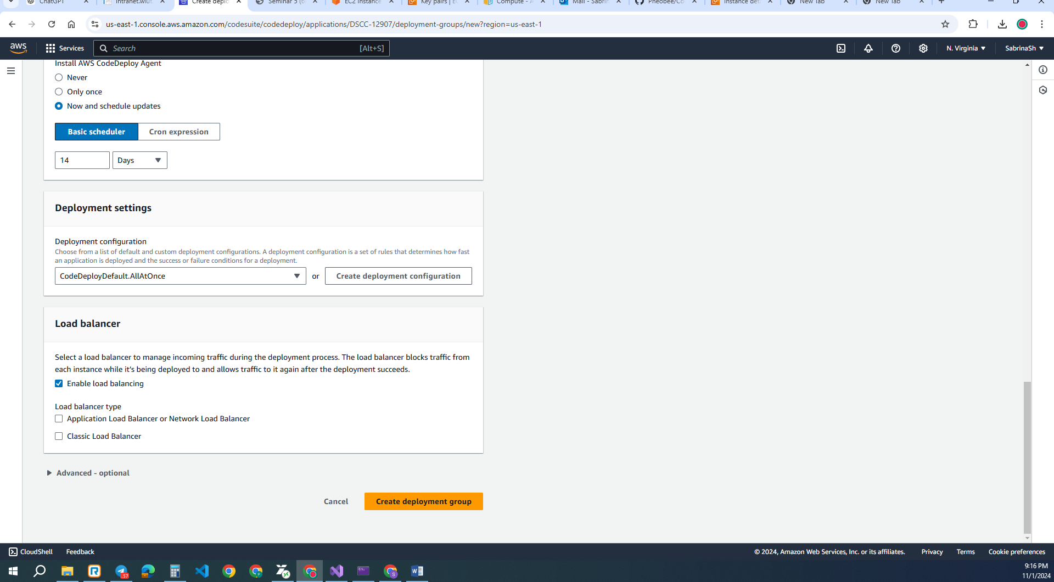

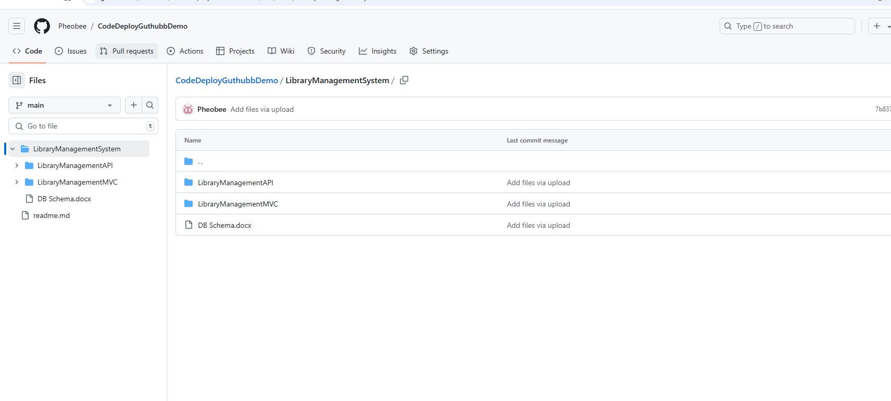

https://github.com/Pheobee/CodeDeployGuthubbDemo.git